Military Use of Pesticides. Toxicity of “Agent Blue”

Lubomir Simeonov, Yordan Simeonov
Space Research and Technology Institute (SRTI)
Bulgarian Academy of Sciences (BAS)
Acad. G. Bonchev Str., Block 1
1113 Sofia, Bulgaria
lubomir.simeonov@gmail.com

Military Use of Pesticides. Toxicity of “Agent Blue”

During the Vietnam War (1960 – 1971), Agent Orange, Agent Blue and other herbicides were sprayed by U.S. military forces at a rate of more than an order of magnitude greater than amounts used for domestic weed control. The herbicides were stored and shipped in 208-litre barrels, and named after the colored band painted on each barrel. They were mostly sprayed over South Vietnam forests to kill crops to deprive Vietcong and North Vietnamese troops of food and to remove the vegetation cover used for concealment, making ambushes more difficult.

Agent Blue was used as a contact herbicide in South Vietnam for rapid defoliation, grassy plant control and rice destruction. Blue was the agent of choice for destruction of rice crops. More than 4 million liters of Agent Blue, also known as Phytar 560-G, was dispensed in the Department of Defense (DOD) herbicide program, according to military herbicide records.

Agent Blue works by rapidly defoliating or desiccating a wide variety of plant species of grasses and grains. It works by uncoupling phosphorylation in plants. It was used in situations requiring rapid defoliation, causing browning or discoloration within one day, with maximum desiccation and leaf fall occur within two to four weeks. By starving rice plants of moisture, the enemy (including millions of rice-growing villagers) would be starved of their most basic food. This formed an essential part of the U.S. government’s “rice-killing operations”.

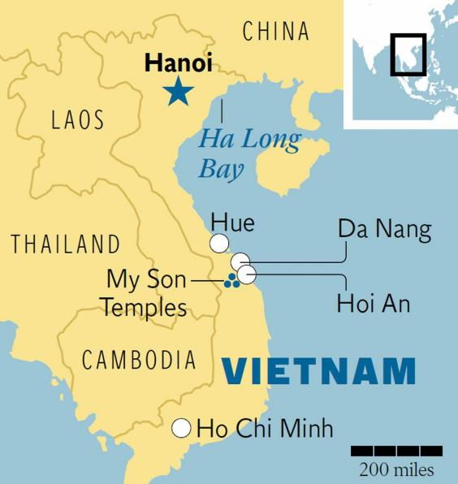

The groundwaters of the Red River alluvial tract in Hanoi, Vietnam are anoxic and rich in iron due to naturally occurring organic matter in the sediments. The problems are caused largely from "tubewells," which pull water from depths of between approximately 10 feet and 40 meters. The wells, designed to provide safe drinking water by avoiding polluted surface waters, inadvertently tapped into arsenic-contaminated underground aquifers. The use of Agent Blue during the Vietnam War and other industrial developments caused the levels of bio-available arsenicals to spike dangerously.
The Rice-killing Military Operation in Vietnam with Agent Blue

US soldiers attempted to blow up rice paddies and rice stocks by using mortars and grenades. But grains of rice were very durable, and were not easily destroyed – every grain that survived was a seed, to be collected and planted again. Soon, the “rice-killing operations” became more sophisticated. Rubber or plastic bladders were dropped directly into rice paddies, exploding on impact and releasing toxic herbicides. Barrels of herbicides were also dropped into the water irrigating rice paddies, polluting rivers and poisoning the soil and people for many years.

Rice Fields in Vietnam

The Toxicity of Agent Blue

Agent Blue contained 4.7 % cacodylic acid (also known as hydroxydimethyarsinine oxide or dimethylarsenic acid, DMAA), and 26.4 % sodium cacodylate as the active ingredients. Cacodylic acid (see its molecular structure on the next slide) is a colorless, odorless, and hygroscopic crystalline solid. It was also commercially available in the form of soluble concentrates. Water solutions of cacodylic acid are sometimes dyed blue. Cacodylic acid is 54 % arsenic. Besides DMAA, another organic arsenical compound, which form the active ingredients of pesticides and herbicides, used mainly for weed control is monomethylarsonic acid (MMAA). MMAA and DMAA are also metabolites of inorganic arsenic formed intracellularly by most living organisms (animals, plants and bacteria).

The term “Agent Blue” was first applied to cacodylic acid in a powder form that was mixed with water in the field. Cacodylic acid is a highly-soluble organic arsenic compound that readily breaks down in soil. It is considered to have very low toxicity to mammals. The original commercial form of Agent Blue was so common and so profitable that it was among 10 toxic insecticides, fungicides and herbicides partially deregulated by the US Environmental Protection Agency (EPA) in February 2004, and specific limits on toxic residues in meat, milk, poultry, and eggs were removed. The World Health Organization guidelines for safety limit of arsenic is at 10 μg/L in drinking water (WHO, 2003). In Vietnam, the legal arsenic concentration limit is five times higher than in the WHO guidelines.

Molecular structure of Cacodylic acid

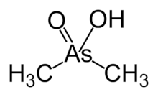 CAS 75-60-5

The routes of entry of cacodylic acid are by ingestion, inhalation, skin and eye contact (irritant), and absorption through the skin. Cacodylic acid is more readily absorbed into the bloodstream when inhaled. It is metabolized by the liver and bioaccumulates in and is excreted by skin, nails and hair. Unlike inorganic arsenicals, DMAA and MMAA do not bind strongly to molecules in humans. Hence, their acute toxicity seem to be less than that of the inorganic arsenicals. However, recent studies indicate that trivalent organic arsenicals that are metabolic products of inorganic arsenic could possibly be more toxic than the parent compound.

The mechanism of toxicity of arsenic include enzyme inhibition and oxidative stress as well as immune, endocrine, and epigenetic effects. Analytical determinations of arsenic poisoning may be made by examining arsenic levels in urine, hair and toenails. Communities and individuals relying on groundwater sources for drinking water need to measure arsenic levels to ensure that their supplies are safe, and communities with arsenic levels greater than 5 μg/L in drinking water should consider a program to document arsenic levels in the population.

Acute Adverse Human Health Effects of Cacodylic Acid
Acute poisoning symptoms and signs usually appear within one hour after ingestion. In individuals who were severely exposed to organic arsenicals, garlicky odor of the breath and feces are experienced, and there may be a salty, metallic taste in the mouth, along with abdominal discomfort. There may also be vomiting, profuse and watery diarrhea, followed by dehydration, electrolyte imbalance, and gradual fall in blood pressure.

Acute effects on the central nervous system start as dizziness, headache, drowsiness and confusion, and may progress to weakened muscles, spasms, convulsions, stupor, general paralysis, coma, and possible death within 3 to 14 days. Death is usually the result of circulatory failure and possibly, renal injury. The oral lethal dose fifty, or LD50 for Cacodylic acid in rats is 644 mg/kg.
Skin contact may cause irritation, burns, rash and loss of pigment. Eye contact may cause irritation, conjunctivitis and burns. Inhalation of Cacodylic acid may irritate the nose and throat and cause ulcers to form on the nasal septum as well as perforations.
A study concluded that the inhibition of glucose uptake may contribute to the acute toxicity, especially of organic arsenicals, by further aggravating the depletion of intracellular carbohydrates.
Chronic Adverse Human Heath Effects of Cacodylic Acid
Because arsenic poisoning of humans can occur by gradual accumulation of small doses until lethal levels are reached, the use of Agent Blue and other organic arsenicals may pose a long-term danger.
Neurological symptoms are usually more frequent than gastrointestinal effects over prolonged exposure of organic arsenicals. Cacodylic acid may cause paresthesias and/or weakness in the hands and feet.

The IARC (International Agency for Research on Cancer – Paris) classifies DMAA and MMAA as possibly carcinogenic to humans (Group 2B). Arsenobetaine and other organic arsenic compounds not metabolized in humans are not classifiable as to their carcinogenicity to humans (Group 3). DMAA induces single strand breaks in DNA, an organ-specific lesion, in the lungs of both mice and rats and in human lung cells in vitro. This damage may be mainly due to the peroxyl radical of DMA and production of reactive oxygen species by lung tissues.
Multi-organ initiation-promotion studies have demonstrated that DMAA acts as a promotor of urinary bladder, kidney, liver and thyroid gland cancers in rats and as a promotor of lung tumors in mice. Lifetime exposure to DMA in diet or drinking water also causes a dose-dependent increase in urinary bladder tumors in rats. DMAA also has the potential to promote rat liver carcinogenesis, possibly via a mechanism involving stimulation of cell proliferation and DNA damage caused by oxygen radicals. It has been proposed that Cacodylic acid may cause lung carcinomas.
Pulmonary carcinogenesis may result from high-dose exposure to Cacodylic acid because both inorganic arsenic and Cacodylic acid share dimethyl- and tri-methylarsine as metabolites; the former has been associated with DNA damage in both rat and mouse lung tissue after high-dose oral acute exposures. Excess lung cancer has been reported in epidemiologic studies of smelter workers who were occupationally exposed primarily to pentavalent arsenic. These and many more studies suggest that DMAA may play a role in the carcinogenesis of inorganic arsenic.

A study concluded that margins of exposure estimated based on conservative estimates of daily intakes of arsenic in all of its forms indicate that exposure to MMAA or DMAA at environmentally relevant exposure levels, by the oral route is unlikely to pose a risk to pregnant women and their offspring. In animal tests with mouse, maternal toxicity was evident at the lowest dose, while teratogenic response was confined to cleft palate at 400 and 600 mg/kg/day. The effective maternal toxic dose in the rat was 40 mg/kg/day.

Repeated skin contact may cause hyperpigmentation and keratosis. Malnourished people have been shown to be more predisposed to arsenic-related skin lesions. White bands may form across the nails.

The acute and chronic effects of commercial organic arsenical herbicides, which were used in a less toxic formulation than Agent Blue as described in the upper slides show a clear evidence for a worse impact on those who were directly exposed to or directly handling Agent Blue in rice paddies during the Vietnam War. Although the acute and chronic effects of organic arsenicals are not as many as that of the inorganic arsenicals, organic arsenicals still have a potential impact on human health which would be greater still as more studies in the future may uncover more of its currently unproven or unknown health effects.

1. Chemicals as Intentional and Accidental Global Environmental Threats, 2006, Lubomir Simeonov and Elisabeta Chirila (eds), NATO Science for Peace and Security, Series C: Environmental Security, Springer Science+Business Media, Dordrecht, ISBN 1-4020-5096-8.
2. Soil Chemical Pollution, Risk Assessment, Remediation and Security, 2008, Lubomir Simeonov and Vardan Sargsyan (eds), NATO Science for Peace and Security, Series C: Environmental Security, Springer Science+Business Media, Dordrecht, ISBN 978-1-4020-8255-9.
3. Exposure and Risk Assessment of Chemical Pollution - Contemporary Methodology, 2009, Lubomir I. Simeonov and Mahmoud A. Hassanien (eds), NATO Science for Peace and Security, Series C: Environmental Security, Springer Science+Business Media, Dordrecht, ISBN 978-90-481-2333-9.
4. Environmental Heavy Metal Pollution and Effects on Child Mental Development, 2011, Lubomir I. Simeonov, Mihail V. Kochubovsky, Biana G. Simeonova (eds), NATO Science for Peace and Security, Series C: Environmental Security, Springer Science+Business Media, Dordrecht, ISBN 978-94-007-0252-3.
5. Environmental Security Assessment and Management of Obsolete Pesticides in Southeast Europe, 2013, L.I.Simeonov, F.Z.Makaev, B.G.Simeonova (eds), NATO Science for Peace and Security, Series C: Environmental Security, Springer Science+Business Media, Dordrecht, ISBN 978-94-007-6460.gricultural

https://toxoer.com

Project coordinator: Ana I. Morales
Headquarters office in Salamanca.
Dept. Building, Campus Miguel de Unamuno, 37007.
Contact Phone: +34 663 056 665

