Adverse Effects of Pesticides on
Reproductive Health and Pregnancy

Lubomir Simeonov, Yordan Simeonov
Space Research and Technology Institute (SRTI)
Bulgarian Academy of Sciences (BAS)
Acad. G. Bonchev Str., Block 1
1113 Sofia, Bulgaria
lubomir.simeonov@gmail.com

Adverse Effects of Pesticides on Reproductive Health and Pregnancy

Pesticide Exposure & Pregnancy

Being in contact with pesticides is harmful, especially during pregnancy. It may lead to miscarriages (spontaneous abortion), preterm births, low birth weight, birth defects and later to learning problems in children.
Living or working in an area with crops, the future mother may be exposed to large amounts of pesticides. During pregnancy it is very important for the future mother to avoid being exposed to pesticides.
Taking precautions even when not pregnant is vital, but specially so if the future mother is planning to be, or if she could be. Often pesticide exposure can happen in the first weeks before a woman realizes she’s pregnant and those first weeks are the most dangerous time for exposure.
Pesticides & Reproductive Health
Many pesticides are endocrine disruptors and interfere with the body’s biological signals. Some chemicals pass through the body quickly, while others are carried through blood and tissue for years. Pesticides are harmful to the reproductive system, sometimes killing cells or damaging cells, resulting in infertility.

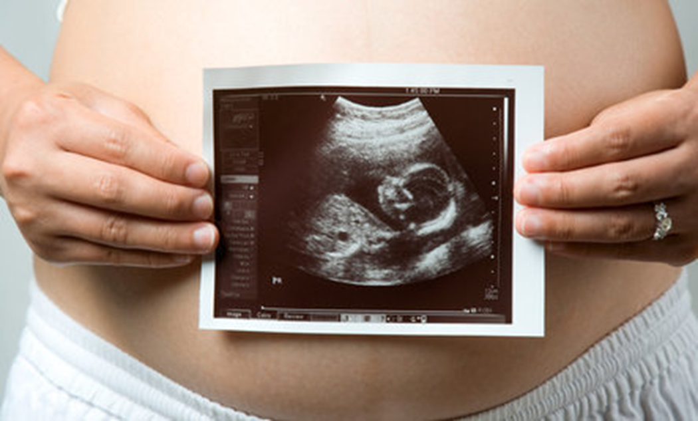

Pesticides have also been implicated in miscarriage, premature birth, reduced fertility in both men and women, altered sex ratio (fewer boys being born) and a number of developmental defects. Research indicates that children exposed to pesticides either in utero (refers to unborn child, prenatal, fetus), or during other critical periods face significant health risks including higher incidence of:
- Birth defects
- Neurodevelopmental delays & cognitive impairment
- Childhood brain cancers
- Autism Spectrum Disorders (ASD)
- Attention-Deficit/Hyperactivity Disorder (AD/HD)
- Endocrine disruption

All pesticides have some level of toxicity and pose some risk during pregnancy.
The risk depends on the toxicity of the pesticide ingredients and how much of the pesticide the mother and the baby are exposed to, while pregnant. During pregnancy, the baby’s brain, nervous system, and organs are developing rapidly and can be more sensitive to the toxic effects of pesticides. Because of this, it is important to minimize exposure to pesticides during pregnancy.

Early exposures to environmental chemicals can result in subtle, invisible changes that affect functioning but are not evident until much later in a child’s development.
These subtle changes that occur during fetal development and in early childhood contribute not only to adverse neurodevelopmental and behavioral changes but also to adult diseases, including obesity and neurodegenerative diseases like Parkinson’s and Alzheimer disease. This is why it is important to minimize exposure to potentially toxic chemicals early in a child’s life.
During the first trimester (3 months) of pregnancy, the nervous system of the baby is rapidly developing , so the future mother would definitely want to avoid any type of contact with pesticides during this time.

Pesticides & Pregnancy: Agricultural Pesticides & Insecticides
Some studies show that the greatest risk of exposure to pesticides is during the first three to eight weeks of the first trimester when the neural tube (brain) development is occurring. If the woman discovers that she is pregnant and she lives near an agricultural area where pesticides are being used, it is advised that she would remove herself to avoid exposure to these chemicals.

Annals of Oncology, Epidemiology, Toxicology and Applied Pharmacology, Journal of Neuroscience, Occupational Environmental Medicine, and the American Journal of Public Health are just some of the journals reporting associations between agricultural pesticides and birth defects, pregnancy complications, and miscarriage.

Pesticides & Pregnancy: Domestic Pesticides & Insecticides
Pregnant women should avoid pesticides, whenever possible. There is no substantial evidence that links exposure to pest-control products at levels commonly used at home to pose a risk to the fetus. However, California’s Defects Monitoring Program reports that three out of every four women are exposed to pesticides around the home, therefore fetus is subject to some form of exposure.
They also observed that pregnant women exposed to household gardening pesticides had a modest risk increase for oral clefts, neural tube defects, heart defects, and limb defects. Women living within 1/4 mile of agricultural crops had the same modest risk increase for neural tube defects.

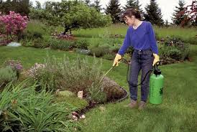

All insecticides are to some extent poisonous and some studies have suggested that high levels of exposure to pesticides may contribute to miscarriage, preterm delivery, and birth defects. Certain pesticides and other chemicals, including PCBs (polychlorinated biphenyls), have weak, estrogen-like (hormone imitating) qualities called endocrine disrupters that some scientists suspect may affect development of the fetus’s reproductive system.

The Environmental Health Perspectives Journal (EHP) Volume 110 reports that children who are exposed to indoor pesticides are at an elevated risk of leukemia. EHP Journal adds that the risk is increased during the first three months of pregnancy and when professional pest control services are used in the home.

Pesticides & Pregnancy: Organic & Natural Pesticides
Almost all toxins used in pesticides are compounds that are naturally present in plants. Although they sound healthier, the terms organic and natural are not synonyms for better or safer.
All chemicals, including natural chemicals, have the potential to cause harm if they are not properly handled.
Make sure you read the warning labels on all pesticide and insecticide packages before handling.
A pregnant woman can reduce her exposure to pesticides by controlling pest problems with less toxic products such for example boric acid.

Helpful Information on Pesticide or Insecticide Use during Pregnancy:
Don’t panic if you realize you have been exposed to a pesticide. Any real risk comes from long-term or intense exposure. If you just treated your dog for fleas and exposed yourself to a pesticide, the risks to your baby are small.
The safest plan is to avoid using pesticides or insecticides in your home, on your pets, or in the garden during pregnancy. Especially avoid them during the first trimester when the baby’s neural tube and nervous system are developing.

If a woman must have her home or property treated with pesticides, a pregnant woman should:
- Have someone else apply the chemicals;
- Leave the area for the amount of time indicated on the package instructions;
- Remove food, dishes, and utensils from the area before the pesticide is used;
Following application of pesticides in the home have someone wash the area, where food is prepared;
Open the windows and allow air flow into the house after pesticides applied.

If pesticide use is occurring outdoors or you live in an agricultural area, a pregnant woman should:
- Close all windows and turn off air conditioning, when pesticides are used outdoors, so fumes do not enter into the house.
- Wear rubber gloves and protective clothing, when working outdoors to prevent skin contact with plants that have pesticide or pesticide residue on them..

Bibliography

- 1. Chemicals as Intentional and Accidental Global Environmental Threats, 2006, Lubomir Simeonov and Elisabeta Chirila (eds), NATO Science for Peace and Security, Series C: Environmental Security, Springer Science+Business Media, Dordrecht, ISBN 1-4020-5096-8.
- 2. Soil Chemical Pollution, Risk Assessment, Remediation and Security, 2008, Lubomir Simeonov and Vardan Sargsyan (eds), NATO Science for Peace and Security, Series C: Environmental Security, Springer Science+Business Media, Dordrecht, ISBN 978-1-4020-8255-9.
- 3. Exposure and Risk Assessment of Chemical Pollution - Contemporary Methodology, 2009, Lubomir I. Simeonov and Mahmoud A. Hassanien (eds), NATO Science for Peace and Security, Series C: Environmental Security, Springer Science+Business Media, Dordrecht, ISBN 978-90-481-2333-9.
- 4. Environmental Heavy Metal Pollution and Effects on Child Mental Development, 2011, Lubomir I. Simeonov, Mihail V. Kochubovsky, Biana G. Simeonova (eds), NATO Science for Peace and Security, Series C: Environmental Security, Springer Science+Business Media, Dordrecht, ISBN 978-94-007-0252-3.
- 5. Environmental Security Assessment and Management of Obsolete Pesticides in Southeast Europe, 2013, L.I.Simeonov, F.Z.Makaev, B.G.Simeonova (eds), NATO Science for Peace and Security, Series C: Environmental Security, Springer Science+Business Media, Dordrecht, ISBN 978-94-007-6460.A

- gricultural

https://toxoer.com

Project coordinator: Ana I. Morales
Headquarters office in Salamanca.
Dept. Building, Campus Miguel de Unamuno, 37007.
Contact Phone: +34 663 056 665

