Toxicity of Obsolete Pesticides

Lubomir Simeonov, Yordan Simeonov
Space Research and Technology Institute (SRTI)
Bulgarian Academy of Sciences (BAS)
Acad. G. Bonchev Str., Block 1
1113 Sofia, Bulgaria
lubomir.simeonov@gmail.com

Toxicity of Obsolete Pesticides

Obsolete pesticides are stocked pesticides that can no longer be used for their intended purpose or any other purpose and therefore require disposal. Obsolete pesticide stockpiles are an international environmental policy issue thus its management needs to be given a global attention to save our resources. In the developing countries and in many Central and Eastern European countries, there are huge stockpiles of pesticides, estimated to be several hundreds of thousands of tones. Estimates show that > 500 000 tons of obsolete pesticides are accumulated globally, especially in developing countries. A considerable amount of the accumulated obsolete pesticides are in the group of persistent organic pollutants (POPs).
Obviously the problems connected with Obsolete Pesticides (OPs) does not concern generally the use of pesticides. Rather the problem is caused by pesticides that have not been used and thereby have become obsolete. The problem – in particular the associated risks stemming from their inadequate management and storage – relates to: Public health and Environmental quality and Agricultural production and trade.
The cause of accumulation of these chemicals has been attributed to lack of appropriate management, misuse of chemicals, uncoordinated chemical donations, substandard storage, poor storekeeping, lack of expertise and financial resources. Other factors include banning or restriction of products for health or environmental reasons e.g. through banning as for the case of those, which were banned or restricted by Stockholm Convention; withdrawal of registration; or policy decision by the Ministry of Agriculture or other authorized ministries. As a result of improper or prolonged storage some products can no longer be used according to its label specifications and instructions for use, nor can it easily be reformulated to become usable again and thus lead to deterioration of these products.

A huge stockpile of obsolete pesticides

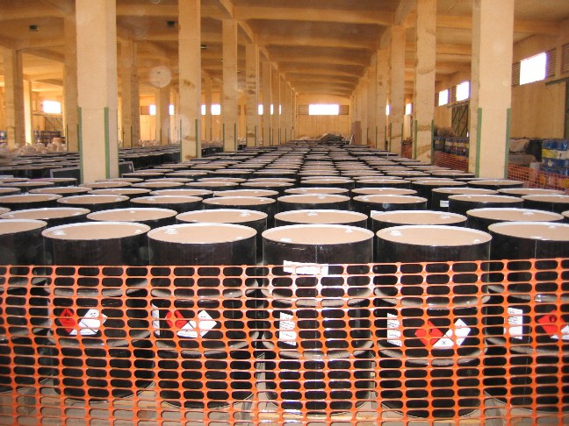

A pesticide product is considered deteriorated when:
- the manufacturers' expiration date has passed;
- the material is "left over" after the pest problem has been resolved; f
- the material was purchased in excess quantities;
- the material is banned because of environmental or public health reasons;
- the material causes an unacceptable hazard to human health or to the environment;
- the material has undergone an unacceptable loss of biological efficacy because of degradation of its active ingredient and/or other chemical or physical changes

- Stocks of obsolete pesticides occur in most of the developing countries and economies in transition. It is estimated that about 500 000 tons are stockpiled worldwide. Obsolete pesticides are placed mostly at 10000 locations of the former Soviet Union, the Southern Balkans and new EU member states. According to FAO (2012), in Central Europe, the highest amounts of obsolete pesticides are placed in the Russian Federation (100 000 tones); Macedonia (38 000 tones); Ukraine (25 000 tones); Uzbekistan (12 000 tones); Belarus (11 000 tons); Kazakhstan (10 000 tons). Outside Central Europe, about 27 400 tons are placed in Africa; 6 500 tons are placed in Asia; 241 000 tons in Eastern Europe and 11 300 tons in Latin America and the Caribbean area.

Police detains A ship full of obsolete pesticides

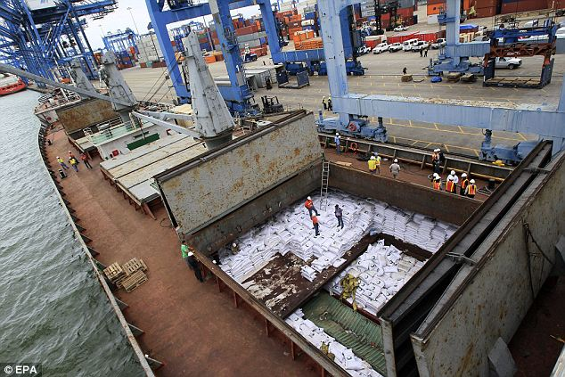

Strategies to reduce human and environmental exposure require more that an isolated exposure assessment; it is not possible to standardize “how to eliminate obsolete pesticides stockpiles” as a site by site approach is needed. Regardless of the local legislation, environmental condition and diversity in the techniques that may be applicable for particular sites at different countries, there are four basic steps that should work as a start to the obsolete pesticides safe containment and removal process.
The accumulation and bad management of obsolete pesticides constitute a threat to human health and the environment, locally, regionally and globally. When located near water sources, obsolete pesticides can pose a high risk of contaminating drinking water sources as well as irrigation water. In turn contaminated irrigation water might introduce pesticide residues into crops and fish, making them unfit for trade as well as for local consumption. Leaking of stockpile can contaminate a significant land area making it unfit for human habitation or for any agricultural activities.

Environmental properties of some obsolete pesticides

Pesticide | Half-life in soil (days) | Koc (L/kg) | Water solubility (mg/L) | H  (atm-m³/mole) | Log BCF (daphnia)
2,4-D | 10 - 30 | 19.6 - 109.1 | 500 | 1.02 E-8 | 0.3
DDT | 2000 | 677,934 | 0.025 | 8.10 E-06 | 4.2-4.4
Chlordane | 4300 | 10,811 | 0.25 | 7.52 E-06 | 3.13-4.0
Chlorpyrifos | 600 | 95,816 | 0.74 | 6.00 E-06 | 3.49-4.84
Dieldrin | 1000 | 25,546 | 0.195 | 1.51 E-05 | 4.1
Heptachlor | 250 | 30,200 | 0.18 | 1.09 E-03 | 4.08
Lindane | 400 | 1,352 | 6.8 | 1.4 E-05 | 1.2 -3.2
Methoxychlor | 350 | 51,310 | 0.056 | 4.86 E-05 | 4.4
Toxaphene | 120 | 80,000 | 0.045 | 1.58 E-05 | “low”

What are the dangers from obsolete Pesticide exposure
In brief:
Fatigue
Skin Irritations
Nausea
Vomiting
Breathing Problems
Liver & Kidney Damage
Reproductive Damage
Cancer
Death
Management of obsolete pesticides
As first an inventory is required, followed by a risk characterization, site stabilization and finally disposal. The inventory will allow to determine which products should be categorized as obsolete pesticides and which are usable. The risk derived by obsolete pesticide stockpiles is a combination of toxicity or hazard of the product and an exposure assessment. The site stabilization has as purpose to decrease the environmental contamination, reducing both risks and accidents. The disposal represents the solution for those products that can no longer be used for their intended purpose and cannot be reformulated to become viable again.

CLEANING OF AN ABANDONED OBSOLETE STORAGE SITE

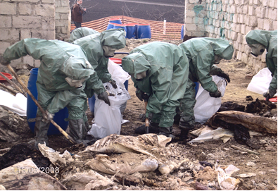

General Conclusion:
Management of obsolete pesticide stockpiles: Because of the enormous chemical complexity, at present the only accepted management option is their immediate environmentally-safe removal and destruction!
Management of environmental pollution with obsolete pesticides and by-products: The prescribed steps for management include: site characterization, sampling, chemical analysis, decision-making, remediation actions.

Bibliography

- 1. Chemicals as Intentional and Accidental Global Environmental Threats, 2006, Lubomir Simeonov and Elisabeta Chirila (eds), NATO Science for Peace and Security, Series C: Environmental Security, Springer Science+Business Media, Dordrecht, ISBN 1-4020-5096-8.
- 2. Soil Chemical Pollution, Risk Assessment, Remediation and Security, 2008, Lubomir Simeonov and Vardan Sargsyan (eds), NATO Science for Peace and Security, Series C: Environmental Security, Springer Science+Business Media, Dordrecht, ISBN 978-1-4020-8255-9.
- 3. Exposure and Risk Assessment of Chemical Pollution - Contemporary Methodology, 2009, Lubomir I. Simeonov and Mahmoud A. Hassanien (eds), NATO Science for Peace and Security, Series C: Environmental Security, Springer Science+Business Media, Dordrecht, ISBN 978-90-481-2333-9.
- 4. Environmental Heavy Metal Pollution and Effects on Child Mental Development, 2011, Lubomir I. Simeonov, Mihail V. Kochubovsky, Biana G. Simeonova (eds), NATO Science for Peace and Security, Series C: Environmental Security, Springer Science+Business Media, Dordrecht, ISBN 978-94-007-0252-3.
- 5. Environmental Security Assessment and Management of Obsolete Pesticides in Southeast Europe, 2013, L.I.Simeonov, F.Z.Makaev, B.G.Simeonova (eds), NATO Science for Peace and Security, Series C: Environmental Security, Springer Science+Business Media, Dordrecht, ISBN 978-94-007-6460.A

https://toxoer.com

Project coordinator: Ana I. Morales
Headquarters office in Salamanca.
Dept. Building, Campus Miguel de Unamuno, 37007.
Contact Phone: +34 663 056 665

