Toxic Effects of Pesticides on Human Body

Lubomir Simeonov, Yordan Simeonov
Space Research and Technology Institute (SRTI)
Bulgarian Academy of Sciences (BAS)
Acad. G. Bonchev Str., Block 1
1113 Sofia, Bulgaria
lubomir.simeonov@gmail.com

Toxic Effects of Pesticides on Human Body
Pesticide is the generic name for a chemical substance or a mixture of substances classified on the basis of the organism killed (pest control) and the pattern of use: insecticides, herbicides, fungicides, rodenticides, acaricides, molluscides, larvacides, scabicides, miticides, pediculicides, defoliants, repellants, desiccants, plant grows regulators, attractants (pheromones).
Plant extracts containing pyrethrin or nicotine and secondary plant metabolites such as phenols, terpenes, alkaloids, tannins, sterols, gums, and sugars were used in agriculture before the discovery of synthetic pesticides, as plant defenses against microbial pathogens or invertebrate pests.
Most of the time, pesticide use involves their deliberate release into the environment for repelling, attracting, preventing, or killing any pests (target organisms) and may affect other organisms from the environment, because they have limited selectivity.
Pesticides are known to be a major environmental hazard because only 5% of the used pesticides reach the targeted pests, while more than 95% of the pesticides, dispersed in the environment reach non-target organisms.
Pesticides are environmental pollutants, which may be described as any physical, chemical, or biological agent, developed to control or kill certain organisms (undesirable plants, animals or microorganisms). As a consequence they have the potential to cause adverse effects to non-target organisms (associations with health effects with different latency periods for the different pesticide classes).
All living organisms are dynamic systems, which function as a result of independent chemical and biochemical reactions that are permanently maintained in equilibrium state. The presence of xenobiotic* substances in a living system can easily disrupt this balance.
Human health is a very complex mixture of elements such as hereditary factors, lifestyle choices (eating habits, exercise, smoking, alcohol, drugs), socio-economic status, access to medical services, and of course the environment. Research has indicated that interaction between the environment and human health is far more complex than is commonly understood.
*A xenobiotic is a foreign chemical substance found within an organism that is not normally naturally produced by or expected to be present within. It can also cover substances that are present in much higher concentrations than are usual. The term xenobiotics is very often used in the context of pollutants such as dioxins and polychlorinated biphenyls and their effect on the biota, because xenobiotics are understood as substances foreign to an entire biological system, i.e. artificial substances, which did not exist in nature before their synthesis by humans. Xenobiotics may be grouped as carcinogens, drugs, environmental pollutants, food additives, hydrocarbons, and pesticides. Wikipedia.

Pollution may be defined as an undesirable change in the physical, chemical or biological characteristics of air, water, soil or food that can adversely affect the health, survival and activities of humans.
The role of toxicology and clinical toxicology is to study the toxic effects of chemical compounds on the human body, and recent developments in biochemistry, clinical biochemistry, biology and genetics can afford us the understanding of the processes at work in the human body in the presence of xenobiotics.
Exposure to xenobiotic substances can produce toxicokinetic effects ( enzymatic induction of metabolic pathway) and toxicodynamic effects (change in gene expression) in the human body.
General definitions for toxic substances:
- poison is legally, a substance that is fatal at a dose of less than 50 mg/kg body weight;
- toxicant is substance that may produce effects on plants, animals or humans;
- toxin is a toxicant, produced during the metabolism of invading living organisms (microorganisms, plants, insects);
- xenobiotic is a chemical that is foreign (not synthesized) into the entire biological system, incl. the human body.
Apart from the expected contributions of lifestyle choices, dietary factors and genetic state, many xenobiotics increase the risk of appearance of biological and health effects.
There are several factors that govern the biological effects of the pollutants and their metabolites in any living organism:
- first, they need to enter the organism and be transported to the target sites, where they need to bind to and interact with their biological receptors;
- or be stored and resist the action of degradative enzymes (i.e. biodegradation).
Solubility is a major determinant for the penetration of pollutants through sell membranes. Water and other biological media solubility influence the mobility of toxins, as blood and lymph serve as pollutants means of transport, while liver, fat tissues, kidney and bone serve as pollutant storage.

Exposure to Pesticides and Effects on Human Health
Exposure to a pollutant (pesticide) is the presence of a certain concentration of pollutant material in the air, water or soil, to which a living organism is exposed.
Dose received by an organism depends by the time of exposure and the quantity of pesticide. Doses are often expressed in weight or molecular units per kilogram of body weight or per square meter of body surface area, while exposure is a concentration of the pollutant compound in the air, water or soil to which the living organism is exposed.
Considering the time of exposure to toxicants, we can distinguish two different types of toxicity:
- Acute toxicity – observed soon after a short-time or one-time exposure to the chemical pollutant;
- Chronic toxicity – resulted after a long term and/or repeated periods of exposure to lower doses of the chemical pollutant.
For humans exposure to pesticide or pesticide residues can follow one or more of a number of pathways: through consumption of contaminated foods or drinking contaminated water, through residential application of pesticides, and in the course of occupational handling of pesticides. Routes of exposure to pesticides can be oral, inhalation and dermal, depending on pollutants physical and chemical properties.
The Pesticide Pathways in Environmental Media (a drawing by R. Cooke, 2000)
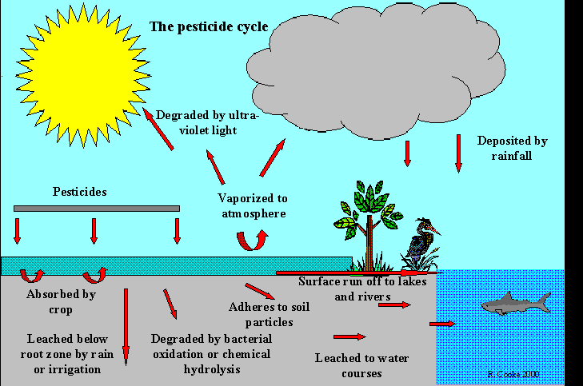

In the EU there is a significant presence of pesticides or pesticide residues in foods and consumers are exposed to more than one pesticide at the same time or in a short span of time:
- 53 to 64% of foods pesticides were not detectable;
- 32-42% of foods contained detectable pesticide levels (below the maximum residue levels-MRL);
- 3 to 5.5% of foods contained levels above the MRL;
- 14 to 23% of foods contained more than one pesticide;
- more than 50% of streams contained five or more pesticides.
On the next drawing are presented the general pesticide pathways and related sources of human exposure to hazardous pesticides.
Sources of Human Pesticide Exposure
Fungicides Pesticides & Pesticide Residues
Drinks & Food
Medicine

Veterinary & Human
Human Pesticides Exposure
Insecticides Pest Control

Agriculture Pest Control
Leisure
Work & Home

Garden (Ornamental) Plants Sport Fields
Travel

Living organisms in general, as well as humans in particular are concurrently exposed to two or more pesticides in their environment, situation that leads to the development of combined toxicological effects. These emerging effects are:
- simple effect or independent action of the individual pesticide where the effect of one pesticide is the same whether the other one is present or not and the combined effects will be the sum of the individual effects.
- dose addition effect or agonist effect, which refers to mixtures of individual pesticides with the same mode of action and the same toxicological effects, which differ only in their potencies.
- interaction effect which is referred to as the joint action, where the combined effects of more pesticides may be greater (synergistic) or less (antagonistic) than the predicted effects.
Most of the pesticides are hydrophobic compounds and tend to accumulate in human (mammalian) fatty tissue and may induce many pathologic states.
The degree of health hazard depends on the quantity of the pesticide and on the length of exposure (the dose of the pollutant).
In the dose–response relationship it is important for the response (effect) to be readily quantified in a reproducible way, relevant to the toxic processes.
The estimation of the dose–effect or concentration–effect relationship for pollutants (pesticides) is using some expressions: LD50 – lethal dose; LC50 – lethal concentration and IC50 – inhibited concentration.
LD50 is the dose which corresponds to a 50% mortality of the exposed organisms and it is a measure for acute toxicity.
LC50 is the concentration in air or water which corresponds to a 50% mortality of the exposed organisms, in a given amount of time.
IC50 is the concentration which corresponds to a 50% inhibition of growth or activity.
Low toxicant concentrations may produce no observable effects, but as the concentration increases towards the critical level, symptoms will appear that will range from the lowest observable effect to severe affectation and even death.
The figure on the next slide shows the cumulative dose-response relationship as a sigmoid curve, where the no observable effect concentrations (NOEC) and lowest observable effect concentrations (LOEC) are represented alongside LC50 (LD50).

Acceptable limits of pesticides or pesticide residues in foods or in the environment are designed based on this dose-response relationship curve, and the usage of pesticides requires authorization.
The degree of health hazard depends on the quantity of the pesticide used and on the length of exposure (the dose of the pollutant).
Most of the acute effects are temporary, but may also cause coma and even death.
Cumulative Dose-Response Curve

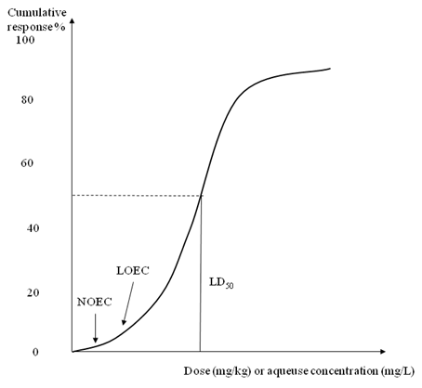

The chronic health effects have a latency period which corresponds to the period of time between the first exposure and the development of the disorder: leukemia, cancer, cirrhosis, lung diseases and asthma, obesity and diabetes, kidney and urinary tract diseases, cardiovascular and hematologic diseases, gastrointestinal disorders, genetic alterations, and pathologic states of the bone marrow, the central nervous system, the blood cells.
Today, in our society, the debate over pesticide use is a social issue and continues at all levels, the controversy resting in the opposition between the rationale for pesticides and the need to minimize the health risks.

Bibliography
- 1. Chemicals as Intentional and Accidental Global Environmental Threats, 2006, Lubomir Simeonov and Elisabeta Chirila (eds), NATO Science for Peace and Security, Series C: Environmental Security, Springer Science+Business Media, Dordrecht, ISBN 1-4020-5096-8.
- 2. Soil Chemical Pollution, Risk Assessment, Remediation and Security, 2008, Lubomir Simeonov and Vardan Sargsyan (eds), NATO Science for Peace and Security, Series C: Environmental Security, Springer Science+Business Media, Dordrecht, ISBN 978-1-4020-8255-9.
- 3. Exposure and Risk Assessment of Chemical Pollution - Contemporary Methodology, 2009, Lubomir I. Simeonov and Mahmoud A. Hassanien (eds), NATO Science for Peace and Security, Series C: Environmental Security, Springer Science+Business Media, Dordrecht, ISBN 978-90-481-2333-9.
- 4. Environmental Heavy Metal Pollution and Effects on Child Mental Development, 2011, Lubomir I. Simeonov, Mihail V. Kochubovsky, Biana G. Simeonova (eds), NATO Science for Peace and Security, Series C: Environmental Security, Springer Science+Business Media, Dordrecht, ISBN 978-94-007-0252-3.
- 5. Environmental Security Assessment and Management of Obsolete Pesticides in Southeast Europe, 2013, L.I.Simeonov, F.Z.Makaev, B.G.Simeonova (eds), NATO Science for Peace and Security, Series C: Environmental Security, Springer Science+Business Media, Dordrecht, ISBN 978-94-007-6460.Agricultural

https://toxoer.com

Project coordinator: Ana I. Morales
Headquarters office in Salamanca.
Dept. Building, Campus Miguel de Unamuno, 37007.
Contact Phone: +34 663 056 665

