**Military Use of**

**Pesticides. Toxicity of “Agent Orange”**

Lubomir Simeonov, Yordan Simeonov

Space Research and Technology Institute (SRTI)

Bulgarian Academy of Sciences (BAS)

Acad. G. Bonchev Str., Block 1

1113 Sofia, Bulgaria

lubomir.simeonov@gmail.com



**Military Use of Pesticides. Toxicity of “Agent Orange”**

Historically the first documented intentions to use the toxic potentials of certain pesticides in military operations consider the efforts of US and Britain collaboration during the late 1940s and '50s to work on the on development of herbicides with applications in warfare. In the 1930s, British research and testing paved the way for the discovery of chemical plant growth regulators that mimic the effect of plant hormones, and their implementation as a tactic in war to destroy enemy crops. **Agent Orange** contains two of these compounds – 2,4-D and 2,4,5-T – and works by provoking plants into frantic growth before they wither and die.

Oil- and water-based formulations of herbicides were used in Vietnam and several other places during wartimes. The herbicides were stored and shipped in 208-litre barrels, and named after the colored band painted on each barrel. These herbicides were produced by U.S. military from companies such as Dow Chemical, Monsanto, Hercules Inc., Diamond Alkali/Shamrock, and Ansul.

During the Vietnam War (1960 1971), Agent Orange and other herbicides were sprayed by U.S. military forces at a rate of more than an order of magnitude greater than amounts used for domestic weed control. These herbicides were mostly sprayed over South Vietnam forests to kill crops to deprive Vietcong and North Vietnamese troops of food and to remove the vegetation cover used for concealment, making ambushes more difficult. This cleared large forest areas hiding sanctuaries and bases, forcing Vietcong and North Vietnamese troops to move or risk discovery and attack. Operation Ranch Hand involved about 8390 spraying missions and sprayed about 72 million liters of herbicides, 11 million of which consisted of Agent Orange.

The Herbicide Military Mission “Ranch Hand” in Southeast Asia (an impressive photo drawing from *Deesillustration.com*)

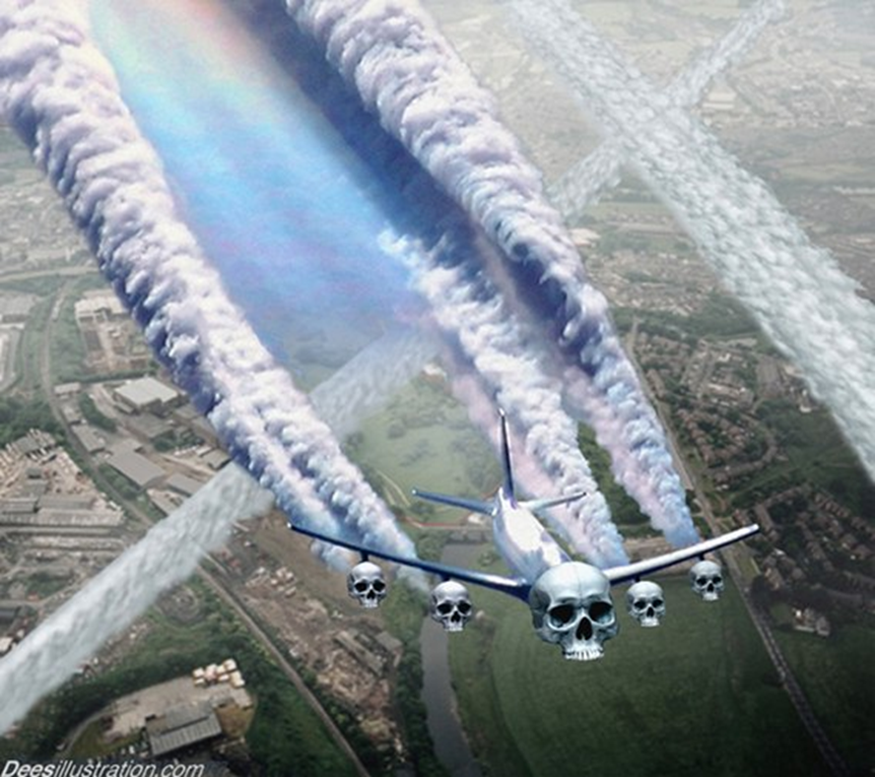

Oil- and water-based formulations of herbicides were used in Vietnam and several other places during wartimes. The herbicides were stored and shipped in 208-litre barrels, and named after the colored band painted on each barrel. These herbicides were produced by U.S. military from companies such as Dow Chemical, Monsanto, Hercules Inc., Diamond Alkali/Shamrock, and Ansul.

During the Vietnam War (1960 1971), Agent Orange and other herbicides were sprayed by U.S. military forces at a rate of more than an order of magnitude greater than amounts used for domestic weed control. These herbicides were mostly sprayed over South Vietnam forests to kill crops to deprive Vietcong and North Vietnamese troops of food and to remove the vegetation cover used for concealment, making ambushes more difficult. This cleared large forest areas hiding sanctuaries and bases, forcing Vietcong and North Vietnamese troops to move or risk discovery and attack. Operation Ranch Hand involved about 8390 spraying missions and sprayed about 72 million liters of herbicides, 11 million of which consisted of Agent Orange.

**Chemistry involved**

Agent Orange is an oil-based herbicide that was used to target broadleaf plants and woody shrubs and trees, incl. mangroves. Agent Orange is a 1:1 mixture of the *n-*butylesters of 2,4-D (2,4-dichlorophenoxyacetic acid) and 2,4,5-T (trichlorophenoxyacetic acid), the molecular structures are given below.

2,4-D 2,4,5-T

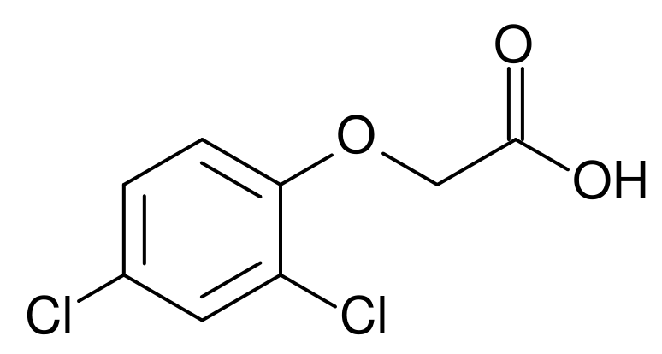 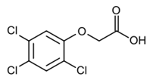

A memo from 1952 concerning an agreement between the U.S. Public Health Service and **Monsanto** about labeling requirements revealed an astonishing use of one of the company's most toxic PCBs. **Monsanto** referred to this as "the prize application” and also referenced cases of *chloracne*, *deaths* associated with exposure to PCBs among workers, and cases of workers' wives developing *acne* and *dermatitis* which was traced back to the halogenated hydrocarbon compounds on clothing of their husbands. In 1966, **Monsanto** defended themselves and stated that when they learned that PCBs could possibly be in the environment, they acted promptly to carry out an investigation to gather information and acted responsibly.

This is an **unavoidable proof** that the companies (look at the upper slides), involved in the production of herbicides, and supplying the military during the warfare spraying were absolutely aware with the toxic properties of the chemicals and what they will cause to human and environmental life.

The Toxicity of Agent Orange

The 2,4,5-T used to produce Agent Orange was unintentionally contaminated during the manufacturing process with small amounts of extremely toxic dioxin compound , 2,3,7,8-TCDD ( 2,3,7,8-tetrachlorodibenzo-p-dioxin).

2,3,7,8-TCDD 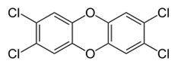

TCDD, which is assigned a toxic equivalency factor (TEF) of **1** has been described as "perhaps the most toxic molecule ever synthesized by man". A daily dose of dioxin concentrations as low as 5 parts per trillion (ppt) can induce a cancerous condition in rats.

Concentrations about 1 part per billion (ppb) result in *premature death* from more acute causes; concentrations of 50 ppb produce rapid signs of acute toxicity and *early death.* Lower concentration of TCDD seem to produce the same effects as higher concentrations, but merely take longer to do so. Concentrations about 1 part per billion (ppb) result in *premature death* from more acute causes; concentrations of 50 ppb produce rapid signs of acute toxicity and *early death*. Lower concentration of TCDD seem to produce the same effects as higher concentrations, but merely take longer to do so.

Maybe the most well-known example of the poisonous properties of dioxin is the case of the third president of Ukraine Viktor Yushchenko (in office from 23 January 2005 to 25 February 2010), a leader of the Orange Revolution for country independence. Following an assassination attempt in late 2004 during his election campaign, Yushchenko was confirmed to have ingested hazardous amounts of TCDD, the most potent dioxin and a contaminant in Agent Orange. He suffered *disfigurement* as a result of the poisoning, but has since made a full physical recovery.

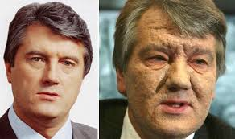

Airborne dioxin can travel great distances and eventually settle onto soil, plants, and water. Dioxin dissolves readily in oils, fats, and organic solvents but poorly in water and it does not evaporate readily. Since dioxin does not react with oxygen or water and is not broken down by bacteria, it persists in the environment for long periods of time. The exposure to dioxins includes both acute exposure by inhalation and skin contact, as was in the case of exposure of military personnel to Agent Orange in Vietnam; and chronic exposure by food and drink, and skin contact from accumulated dioxins in the environment. Half-life of TCDD in humans was estimated to be in the range of 7 to 10 years.

In the vicinity of former U.S. military bases such as Bien Hoa, where Agent Orange was stored in large quantities, soil sampled had TCDD levels that were 180 million times above the safe level set by the U.S. Environmental Protection Agency.

A huge open-air storage of Agent Orange corroding barrels on Johnstone Island, an atoll in South Pacific.

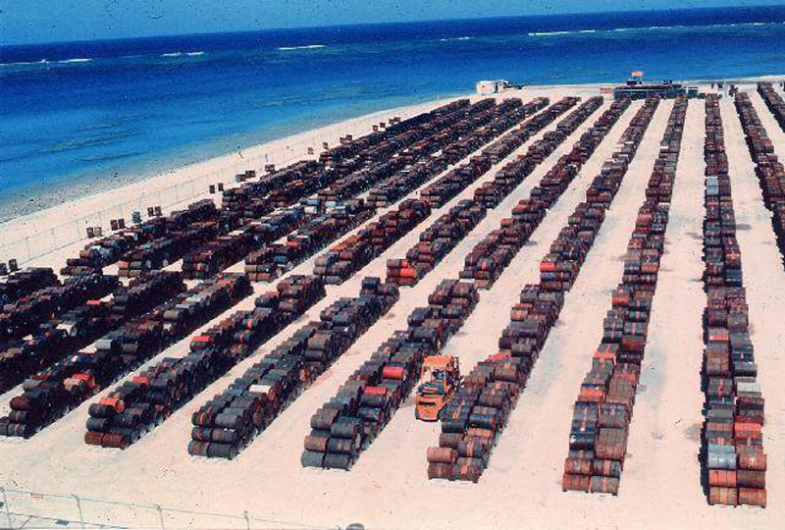

Adverse Human Health Effects of Agent Orange

Millions of Vietnamese people were exposed to Agent Orange during the war. The Vietnamese Red Cross says local studies have shown that as many as a million people now have *disabilities* or other health problems associated with Agent Orange - approximately **100,000** of them being *disabled children.* Every year, particularly in the areas heavily sprayed with Agent Orange, thousands of children are born with *illnesses and birth deformities*, some of them very severe, while thousands of adults develop *cancer* or other health problems.

Officials from the U.S. Department of Veteran Affairs (VA) estimate that about **2.6 million military personnel** who served in Vietnam were affected by Agent Orange. Since 1994, the U.S. government has directed the Institute of Medicine (IOM) to issue reports every 2 years on the health effects (both *cancerous* and *non-cancerous*) of Agent Orange and similar herbicides, titled “Veterans and Agent Orange,” to provide a basis for government policy decisions. Each health effect is categorized as having one of the following: sufficient evidence of an association; limited / suggestive evidence of an association; inadequate / insufficient evidence to determine whether an association exists; or limited / suggestive evidence of no association.

Severe acute intoxication of dioxin may cause *nausea, headaches, vertigo, vomiting, irritation of eyes, skin* and *respiratory tract*, *profuse sweating* with *extensive dehydration* and *weight loss*, *temperature dysregulation*, severe breathing difficulties, cyanosis, and a deteriorating general status, followed after several days to weeks by *chloracne, porphyria, transient hepatotoxicity,* and *peripheral and central neurotoxicity.*

Chronic persistence of TCDD in the human body can be present several decades after massive exposure, and may lead to *atherosclerosis, diabetes, hypertension, vascular ocular changes,* and signs of *neural system damage*, including *neuropsychological impairment*. Such chronic effects are nonspecific, multifactorial, and may be causally linked only to severely intoxicated subjects. This opinion is supported by the dose-dependent effect of TCDD found in exposed workers and by experimental animal studies. Long-term exposures to dioxins may cause *disruption of the immune, reproductive, and endocrine system*, and that the most sensitive population to dioxin exposure are fetuses and infants.

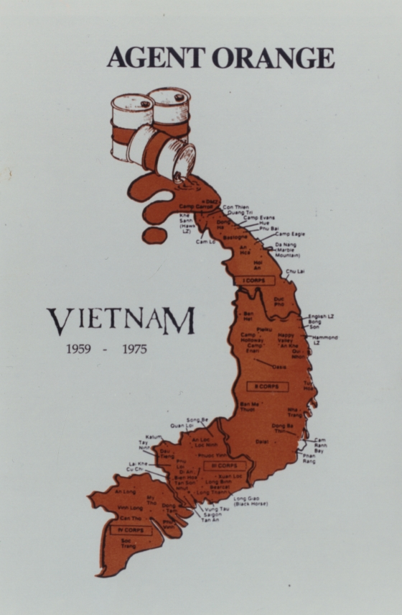

The International Agency for Research on Cancer (IARC) has classified TCDD as a group 1 carcinogen. Studies involving thousands of Vietnam veterans, which potentially provide the most direct evidence of the health effects of Agent Orange exposure, and studies of 3 other groups, have provided important information about the carcinogenicity of Agent Orange. Each of these groups differs in the characteristics of the people exposed, the nature of the dioxin exposures, and other factors such as diet and other chemical exposures. The 3 other groups are: first, Vietnamese soldiers and civilians, often exposed for longer periods; second, workers exposed to herbicides in other settings, such as herbicide manufacturing workers, herbicide applicators, farmers, lumberjacks, and forest and soil conservationists, who often had higher blood dioxin levels than Vietnam veterans; third, people exposed to dioxins after industrial accidents in Germany, Seveso (Italy), and California, and after chronic exposures at work and in the environment.

Links between herbicides (including Agent Orange) and cáncer



Other diseases or medical conditions that have been attributed to Agent Orange exposure (***see the table on next slide***) include *developmental abnormalities*, *thyroid dysfunction*, elevated *serum cholesterol* and *triglycerides*, *liver damage, skin rashes, hypertrichosis, gum pigmentation, eyelid pathology, nausea, vomiting*, and *loss of appetite, death from cardiovascular disease and ischemic heart disease*, *enamel hypomineralization* of permanent first molars in children, *increased levels of serum luteinizing* and *follicle-stimulating hormones*, and *decreased levels of serum testosterone*.

*Chloracne* is the “hallmark of dioxin toxicity” and is the most consistent manifestation of dioxin intoxication, but not all persons exposed to dioxin developed chloracne. Symptoms include a *hyperproliferative reaction* of the cutaneous epithelium with *squamous metaplasia* of the cells lining the ducts of skin glands, resulting in *comedones, cysts*, and, in severe cases, *pustules*. The skin areas most frequently affected are those that are usually in contact with hands contaminated by TCDD: under the eyes, behind the ears, neck, back and genital regions.

Links between herbicides (including Agent Orange) and other health effects



Biblioraphy

1. Chemicals as Intentional and Accidental Global Environmental Threats, 2006, Lubomir Simeonov and Elisabeta Chirila (eds), NATO Science for Peace and Security, Series C: Environmental Security, Springer Science+Business Media, Dordrecht, ISBN 1-4020-5096-8.

2. Soil Chemical Pollution, Risk Assessment, Remediation and Security, 2008, Lubomir Simeonov and Vardan Sargsyan (eds), NATO Science for Peace and Security, Series C: Environmental Security, Springer Science+Business Media, Dordrecht, ISBN 978-1-4020-8255-9.

3. Exposure and Risk Assessment of Chemical Pollution - Contemporary Methodology, 2009, Lubomir I. Simeonov and Mahmoud A. Hassanien (eds), NATO Science for Peace and Security, Series C: Environmental Security, Springer Science+Business Media, Dordrecht, ISBN 978-90-481-2333-9.

4. Environmental Heavy Metal Pollution and Effects on Child Mental Development, 2011, Lubomir I. Simeonov, Mihail V. Kochubovsky, Biana G. Simeonova (eds), NATO Science for Peace and Security, Series C: Environmental Security, Springer Science+Business Media, Dordrecht, ISBN 978-94-007-0252-3.

5. Environmental Security Assessment and Management of Obsolete Pesticides in Southeast Europe, 2013, L.I.Simeonov, F.Z.Makaev, B.G.Simeonova (eds), NATO Science for Peace and Security, Series C: Environmental Security, Springer Science+Business Media, Dordrecht,  ISBN 978-94-007-6460.gricultural



<https://toxoer.com>

Project coordinator: Ana I. Morales

Headquarters office in Salamanca.

Dept. Building, Campus Miguel de Unamuno, 37007.

Contact Phone: +34 663 056 665