**Approaches and Procedures   
for Legislation of Pesticides   
in the European Union**

Lubomir Simeonov, Yordan Simeonov

Space Research and Technology Institute (SRTI)

Bulgarian Academy of Sciences (BAS)

Acad. G. Bonchev Str., Block 1

1113 Sofia, Bulgaria

lubomir.simeonov@gmail.com



**Approaches and Procedures for**

**Legislation of Pesticides in**

**European Union**

Plant protection products (PPPs), or pesticides (insecticides, fungicides, herbicides) are chemical formulations which consist of one or more active ingredients (or active substances) and other ingredients. Their role is the protection of plants and crops in agriculture, horticulture, forestry and gardening. While plant protection products differ in many ways from other chemical substances produced by humans, especially for manufacturing and industrial uses, they share several similarities with pharmaceuticals:

1. Pesticides are produced to control living species and therefore they are necessarily toxic;

2. Pesticides are deliberately spread into the environment to reach their targets, and therefore can be source of environmental pollution and human exposure (workers and consumers);

3. Pesticides are produced to fight against pests, but the specificity of their toxicity for their targets is limited, therefore their use can endanger non target species, from useful insects such as bees to humans.

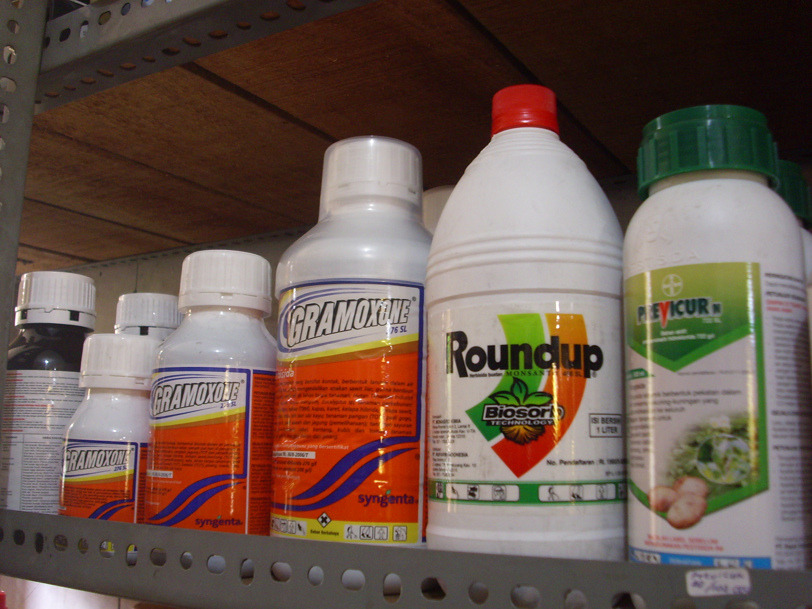

Moreover, it is accepted that without the use of pesticides a significant proportion of the agricultural production goes lost to spoilage (see next slide) in the fields and to rotting and deterioration throughout the production and distribution process, in particular in tropical countries, their use is unavoidable. In this perspective, the environmental and health risks related with their use need to be balanced by the benefit they yield to agricultural production and, in the fight to disease-bearing parasites, to the benefit to environmental and public health.

A Typical Advertising for the Positive Role of Pesticides in Agriculture and Food Production

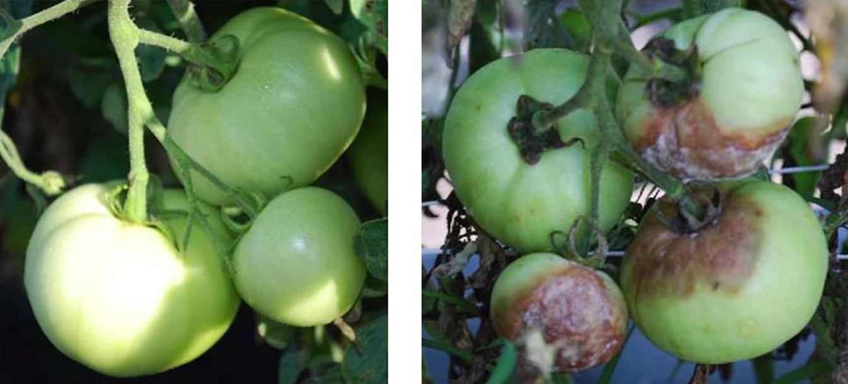

An increased awareness of the potential threats of uncontrolled use of substances of poorly known toxicity led to a substantial change in the approach, gradually resulting into an improved legislation in Western Europe and in other developed countries, to the point that today licensed PPPs are among the substances, of which the chemical and toxicological properties are best known, much before their introduction into the market and even better than requested for human pharmaceutical drugs. It is important to trace the pathway which leads to the birth of new PPPs and to their authorization according to the legislation of the European Union. In particular, while active substances are licensed for use in a ‘*positive list*’ at EU level, the different formulations suitable for use on different cultivations are authorized for the different geographical areas of EU with a ‘mutual recognition’ procedure between member States.

Protection of agricultural workers, of consumers, of the environment are embedded into the authorization procedure by requesting that targeted studies run under normalized conditions are conducted prior to marketing.

Several chemical and toxicological parameters which are pivotal to risk assessments towards humans, non-target plants and animals are measured and health-based safety levels are established for agricultural workers, for bystanders, for the general population, for the residual presence of the active substance and of its decomposition products in food and in natural drinkable water. For enhanced safety, authorization is released in 10-year periods, in order that unexpected harmful consequences for man and environment can be timely examined and, in case, tackled.

The financial cost of this procedure is, of course, not without consequences. Since authorizations are issued in 10-year periods and are subject to voluntary rejuvenation by the licensees, there is a pressure to invest in newer, more profitable active substances rather than to keep into market older ones, which may be as efficient and cheaper, but for which the faintest evidence of health or environmental hazard may prematurely terminate corporate interest. The genesis of EU legislation will be discussed and examples will be brought to highlight key issues.

Well alike pharmaceuticals, and different from most other commodities and consumer products, plant protection products (pesticides) are long subject to pre-marketing authorization process which calls for knowledge of key information (physical, chemical, environmental and toxicological) characteristics to perform scenario-specific risk assessment. The introduction of the **REACH** (Regulation on Evaluation and Authorization of Chemicals) for nearly all industrial and consumer products takes most of its principles from the experience gained in the risk assessment of these high value-added products.

In this sense, the role of regulation processes is therefore to keep under constant control the consequences of the use of pesticides, with reference to a risk-benefit evaluation, and to prevent serious consequences to human health and to environment self-sustainability related to the use of these compounds.

Since the Council Directive of 1991, the European Union recognizes that plant production is very important for agriculture, and plant protection products are one of the most important ways of protecting plants and plant products against harmful organisms, including weeds, and of improving agricultural production.

Pesticides are one of the best examples to follow the thread of the development of risk assessment of chemical substances. In this sense, most suitable is the history of DDT (**D**ichloro**d**iphenyl**t**richloroethane), passing through the stages as: first synthesis in 1874; discovery of strong insecticidal properties in 1939; great success to control *malaria* and *typhus* among civilians and military personnel; recognition to be the best known and the most useful insecticide in stability, persistence, low cost, low mammalian toxicity and broad spectrum of application reaching a peak of 400 000 tons in agriculture and household in 1960.

The next stages of DDT history are marked by the gradual awareness rising and understanding, that the chemical is a toxin that emerges in the food chain; investigations of the bioaccumulation and bio-magnification properties of DDT gave the link to possible adverse effects on human health; the last stages of were marked by gradual decrease of production and finally to generalized international ban of production and application.

The same fate was followed by several other pesticides, which all carry common chemical characteristics, leading to very long persistence in the environment, to transmission through the human food chain and by potential long-term toxicity.

The Public Perception of failures of pesticide regulation leading to strong public health concern and severe and persistent environment contamination has been a strong driving force towards improvement and harmonization of requirements for authorization of plant protection products.

The approach, which is currently adopted for regulation of pesticides is “reactive/preventive”, since it:

1. responds (‘reactive’) to damaging impacts, for which there is convincing evidence of cause-effect relationship and

2. takes regulatory action to ensure that similar impacts do not arise with new generation chemicals (‘preventive’).

This approach grew in time to require the evaluation of toxic effects of new designer chemical entities to be used as PPPs towards several tens of different living organisms. As a consequence, knowledge of the biological effect of pesticides is even wider than that on pharmaceutical drugs, since it also covers toxicity towards non-target species and environmental fate.

The regulatory system for new chemical substances was therefore conceived to avoid to the widest possible extent the hazardous consequences of new products before they reach the market, rather than ex-post, on a case-by-case basis.

development of new pesticides

Developing new pesticides thus means finding chemical entities with multiple requirements as:

• activity towards the targeted living species (weed, insect, warm-blood animal) through interference with an appropriately vulnerable biological pathway, which can develop at practically attainable doses;

• resistance to the environmental conditions of field application (sunlight, rain, high temperatures), in order that biologically active doses can reach the targeted living species;

• sufficient selectivity towards the targeted living species, i.e., at environmental levels the product does not display toxicity towards non-target species, including humans, innocuous plants and insects, wildlife animals and fish, crops (including the plants to be treated), pollinating insects;

• farmer, consumer and environment safety, i.e., can be employed in such conditions that agricultural workers are exposed at levels below which there is concern for their health. the residues of the product do not enter into the human food chain and persist into food and water at levels above those of concern for health of the general population; the applied product does ot persist in the environment after its efficacy is no longer required at levels of no concern for non-target species;

• marketability, i.e., can be protected by patents, manufactured, authorized, delivered worldwide and applied safely in a range of climatic conditions, at a sustainable cost for the farmer.

While in 1972 *only* approx. 10000 different chemical substances had to be screened for characteristics in order to find one active substance to be suitable for the market, in 2001 this number rose by 20 fold, meaning that 200000 chemicals need to be screened to weed out one with all the required characteristics.

The scheme on the next slide outlines the general pathway followed for the selection of new candidate active substances and in their development as PPPs in industrial research. This pathway is closely similar to that followed to develop pharmaceutical drugs. Both activities are currently run in a global, highly competitive and highly regulated environment where fundamental research is aimed at investigating the molecular mechanisms of the physiology of target organisms, to seek unique metabolic pathways the disruption of which leads to death.

General Pathway Followed for the Selection of New Candidate Active Substances



Development of Selected Active Substances and their Pathway as Pesticides in Industrial Research



Chemical compounds able to interfere with target organism viability or with specific sensitive pathways are now selected with high-throughput screening platforms based on complex robotics, which enable them to test over 100,000 potential active molecules per year against whole living organisms or cultivated tissues. Potentially active molecules in agrochemical research are mainly of synthetic origin rather than natural substances as now increasingly common in pharmaceutical research, although there are several exceptions.

In the European Union (EU), no plant protection product can be used unless it has first been scientifically established that:

(a) they have no harmful effects on consumers, farmers, local residents and passers-by; (b) they do not cause unacceptable effects on the environment; (c) they are sufficiently effective against target pests. As a direct consequence, the components of plant protection products placed on the market must not adversely affect human or animal health or the environment.

The current regulation also allows the States members of the European Union to apply the Precautionary Principle where there is scientific uncertainty as to the risk with regard to human or animal health or the environment posed by the plant protection products.

Complex Procedure Leading to Authorization of a New Active Substance as PPP in the European Union



The European Union will authorize only active substances that:

- are sufficiently effective under reasonable conditions of use;

- do not have immediate or delayed harmful effect on human health, including that of vulnerable groups and on animal health, directly or through drinking water, food, feed or air, or consequences in the workplace or through other indirect effects;

- do not have any unacceptable effects on plants or plant products;

- do not cause any unnecessary suffering and pain to vertebrates to be controlled;

- do not have any unacceptable effects on the environment.

For each authorized active substance it is indicated the status and outcome of the authorization procedure. So far, after 2012, nearly 500 active substances have been authorized.



Bibliography

1. Chemicals as Intentional and Accidental Global Environmental Threats, 2006, Lubomir Simeonov and Elisabeta Chirila (eds), NATO Science for Peace and Security, Series C: Environmental Security, Springer Science+Business Media, Dordrecht, ISBN 1-4020-5096-8.

2. Soil Chemical Pollution, Risk Assessment, Remediation and Security, 2008, Lubomir Simeonov and Vardan Sargsyan (eds), NATO Science for Peace and Security, Series C: Environmental Security, Springer Science+Business Media, Dordrecht, ISBN 978-1-4020-8255-9.

3. Exposure and Risk Assessment of Chemical Pollution - Contemporary Methodology, 2009, Lubomir I. Simeonov and Mahmoud A. Hassanien (eds), NATO Science for Peace and Security, Series C: Environmental Security, Springer Science+Business Media, Dordrecht, ISBN 978-90-481-2333-9.

4. Environmental Heavy Metal Pollution and Effects on Child Mental Development, 2011, Lubomir I. Simeonov, Mihail V. Kochubovsky, Biana G. Simeonova (eds), NATO Science for Peace and Security, Series C: Environmental Security, Springer Science+Business Media, Dordrecht, ISBN 978-94-007-0252-3.

5. Environmental Security Assessment and Management of Obsolete Pesticides in Southeast Europe, 2013, L.I.Simeonov, F.Z.Makaev, B.G.Simeonova (eds), NATO Science for Peace and Security, Series C: Environmental Security, Springer Science+Business Media, Dordrecht, ISBN 978-94-007-6460.

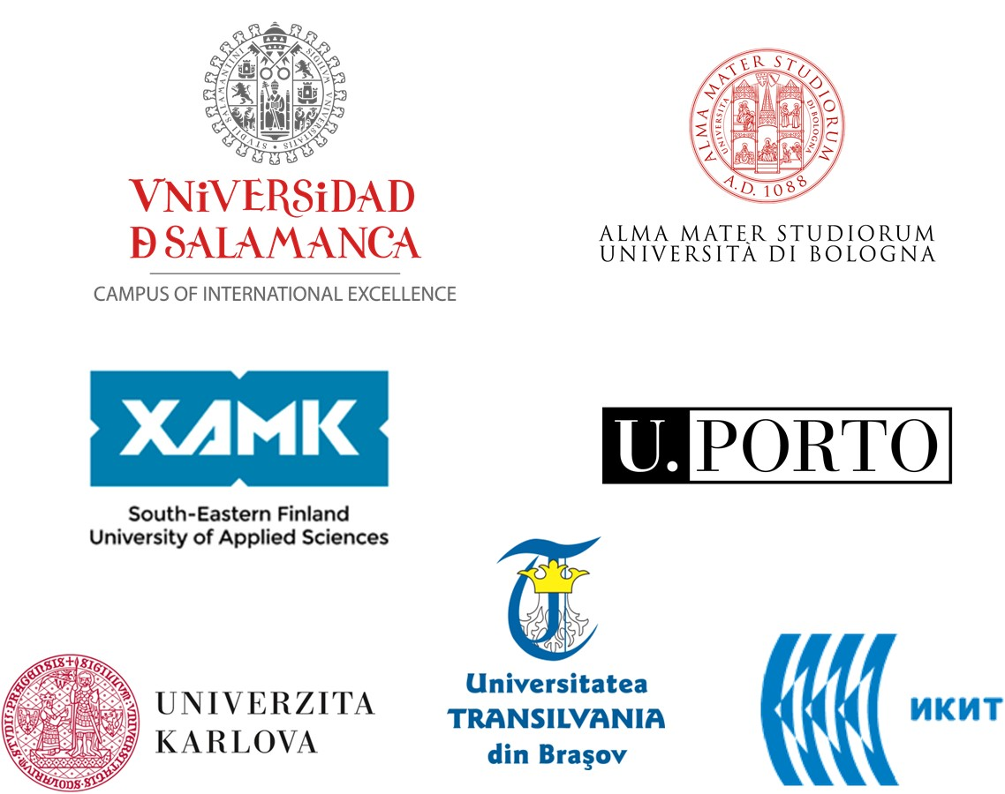

<https://toxoer.com>

Project coordinator: Ana I. Morales

Headquarters office in Salamanca.

Dept. Building, Campus Miguel de Unamuno, 37007.

Contact Phone: +34 663 056 665