Pesticides
Historical overview

Lubomir Simeonov, Yordan Simeonov
Space Research and Technology Institute (SRTI)
Bulgarian Academy of Sciences (BAS)
Acad. G. Bonchev Str., Block 1
1113 Sofia, Bulgaria
lubomir.simeonov@gmail.com

Pesticides. Historical Overview
Protection of crops from pests and from ravenous animals was long accomplished with the use of ‘natural’ means, and it is now more than 5,000 years that selective growth of plant biomass is the main strategy, through which mankind has sought its sustainment. Agriculture is a non-sustainable activity, which depletes unscathed soil of its stored chemical nutrients, which need to be replenished by fertilization. As a result, an artificial ecosystem is produced, in which the natural equilibrium is modified. These issues were solved, often separately, across the history of humankind by different means, which gradually entailed increasing levels of complexity to yield the agro-industrial complex of present times. Cut-and burn, Culture rotation and Chemical fertilization which was chronologically the last step, which uses agricultural land as the physical support of plant growth by feeding externally produced nutrients: nitrogen, phosphorus, potassium.
The concept of pesticides is not new. Around 1000 b.c. Homer referred to the use of sulfur to fumigate homes and by 900 b.c.e. the Chinese were using arsenic to control garden pests. Although major pest outbreaks have occurred, such as potato blight (Phytopthora infestans ), which destroyed most potato crops in Ireland during the mid-nineteenth century, not until later that century were pesticides such as arsenic, pyrethrum, lime sulfur, and mercuric chloride used. Between this period and World War II, inorganic and biological substances, such as Paris green, lead arsenate, calcium arsenate, selenium compounds, lime–sulfur, pyrethrum, thiram, mercury, copper sulfate, derris, and nicotine were used, but the amounts and frequency of use were limited, and most pest control employed cultural methods such as rotations, tillage, and manipulation of sowing dates.
In 1898, Sir William Crookes warned: “England and all civilized nations stand in deadly peril. As mouths multiply, any drop in wheat production will threaten racial starvation”. In 1912 the German chemist Fritz Haber developed the industrial synthesis of ammonia from atmospheric nitrogen, for which he was awarded the Nobel Prize for Chemistry in 1919. To ensure high crop yields the use of chemical pesticides was exploited as early as the mid-XIX century, when the efficacy of copper sulphate against downy mildews (Peronospera), a fungus pest of vineyards, was discovered by Pierre-Marie-Alexis Millardet and the use of the Bordeaux Mixture was popularized. It was only after the expansion of specialty organic chemistry production that organic pesticides were developed, starting from DDT, the discovery of which in 1939 earned Paul Hermann Muller the 1948 Nobel Prize in Physiology or Medicine.
Agricultural progresses played a pivotal role in sustaining the exponential increase of world population since the late XIX century and protection of crops –along with mechanization of processes, chemical fixation of nitrogen and availability of improved cultivars- has since been one of the key factors into the process. In particular, the introduction of synthetic organic chemicals in the second half of the XX century not only boosted the capability to counter crop- and food-spoiling organisms but also allowed to eradicate or control parasite-borne health- and life-threatening diseases such as malaria, both improving the quality of life of large populations in temperate and semi-tropical areas and allowing better utilization of agricultural areas.
Pesticides are substances or a mixture of substances, of chemical or biological origin, used by human society to mitigate or repel pests such as bacteria, nematodes, insects, mites, mollusks, birds, rodents, and other organisms that affect food production or human health. They usually act by disrupting some component of the pest's life processes to kill or inactivate it. In a legal context, pesticides also include substances such as insect attractants, herbicides, plant defoliants, desiccants, and plant growth regulators.

Pests
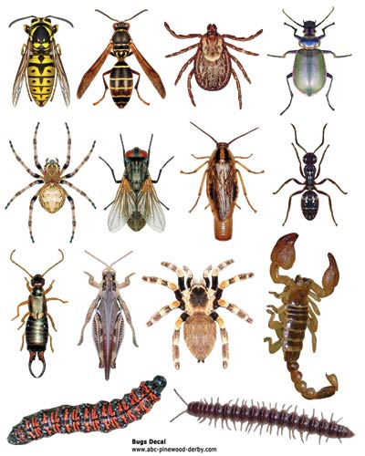

By World War II, only about 30 pesticides existed. Research during the war yielded DDT (dichloro-diphenyl-trichloro-ethane), which had been synthesized in 1874 but wasn't recognized as an insecticide until 1942. Other strong pesticides soon followed, such as Chlordane in 1945 and Endrin in 1951. Poison gas research in Germany yielded the organophosphorus compounds, the best known of which is Parathion. These new pesticides were very strong. Further research yielded hundreds of organophosphorus compounds, the most noteworthy being Malathion, which was recently used in California against the medfly.
At present, some 900 active chemical pesticides are used to manufacture 40,000 commercial preparations. The USA Environmental Protection Agency (EPA) estimates that the use of pesticides doubled between 1960 and 1980. Currently, over 372 million kilograms a year are used only in the United States, with over 1.8 billion kilograms a year used worldwide.

Farmers Spraying Pesticides

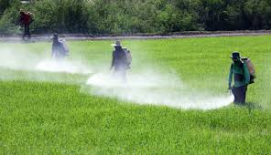

Until the 1900s, when people began to spray personal gardens using fairly large machines, pesticides were generally applied by hand. Airplanes were not used until the 1920s, and slow, well-controlled, low-level flights were not implemented until the 1950s. The first aerial spraying of synthetic pesticides used large amounts of inert materials, 4000 liters per hectare (a hectare equals 2.47 acres). This quantity was rapidly reduced to 100 to 200 liters/hectare, and by the 1970s the amount had been reduced (in some cases) to 0.3 liters per hectare of the ingredient itself (for example, malathion) applied directly to the fields.

Spraying Pesticides by Airplanes
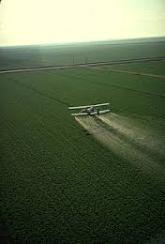

Primary benefits of application of pesticides:

1. Controlling pests and plant disease vectors
  - Improved crop/livestock yields;
  - Improved crop/livestock quality;
  - Invasive species controlled.

2. Controlling human/livestock disease vectors and nuisance organisms
  - Human lives saved and suffering reduced;
  - Animal lives saved and suffering reduced;
  - Diseases contained geographically.

3. Controlling organisms that harm other human activities and structures
  - Drivers view unobstructed;
  - Tree/brush/leaf hazards prevented;
  - Wooden structures protected.

The Most Important Vector-Born Diseases in World Regions

Disease | Vector | Africa | Latin America | Medditerranean Egypt, Iran, Iraq | South-east Asia  India, Indonesia | Western Pacific  China , Vietnam
Malaria | Mosquitoes | + | + | + | + | +
Trypanosomias | Tzetze Fly | +
Onchocercialis | Fly | + |  | +
Leichmaniasis | Insects | + | + | + | +
Shistomiasis | Moluscs | + |  | + |  | +
Lymphatic Filarisasis | Helminths | + | + | + | + | +
Dengue | Mosquitoes |  | + | + | + | +

Synthetic chemical compounds, used as pesticides played an important role in the Green Revolution to increase agricultural production and in eradicating or controlling parasite-borne diseases such as malaria in temperate and sub-tropical areas of the world. However, their impact on environmental biodiversity was not negligible due to their environmental persistence, poor biodegradation and biomagnification into and along the planetary trophic network. Also their effect on the long-term health of the different sub-groups of the human population needs a thorough assessment based on sound toxicological knowledge, on accurate dosimetry in the different scenarios and on responsible evaluation of risk/benefit relationship.

The issues of pesticides pollution of different environmental media as soil, water and air, as well as the toxicological effects of this pollution on human body will be discussed in separate presentations. A special presentation will be dedicated on the process of awareness rising and the most important international conventions and agreements for control and management of hazardous pesticides.

Bilbliography
- Chemicals as Intentional and Accidental Global Environmental Threats, 2006, Lubomir Simeonov and Elisabeta Chirila (eds), NATO Science for Peace and Security, Series C: Environmental Security, Springer Science+Business Media, Dordrecht, ISBN 1-4020-5096-8.
- Soil Chemical Pollution, Risk Assessment, Remediation and Security, 2008, Lubomir Simeonov and Vardan Sargsyan (eds), NATO Science for Peace and Security, Series C: Environmental Security, Springer Science+Business Media, Dordrecht, ISBN 978-1-4020-8255-9.
- Exposure and Risk Assessment of Chemical Pollution - Contemporary Methodology, 2009, Lubomir I. Simeonov and Mahmoud A. Hassanien (eds), NATO Science for Peace and Security, Series C: Environmental Security, Springer Science+Business Media, Dordrecht, ISBN 978-90-481-2333-9.
- Environmental Heavy Metal Pollution and Effects on Child Mental Development, 2011, Lubomir I. Simeonov, Mihail V. Kochubovsky, Biana G. Simeonova (eds), NATO Science for Peace and Security, Series C: Environmental Security, Springer Science+Business Media, Dordrecht, ISBN 978-94-007-0252-3.
- Environmental Security Assessment and Management of Obsolete Pesticides in Southeast Europe, 2013, L.I.Simeonov, F.Z.Makaev, B.G.Simeonova (eds), NATO Science for Peace and Security, Series C: Environmental Security, Springer Science+Business Media, Dordrecht, ISBN 978-94-007-6460.

https://toxoer.com

Project coordinator: Ana I. Morales
Headquarters office in Salamanca.
Dept. Building, Campus Miguel de Unamuno, 37007.
Contact Phone: +34 663 056 665

