Inventories of Obsolete Pesticides

Lubomir Simeonov, Yordan Simeonov
Space Research and Technology Institute (SRTI)
Bulgarian Academy of Sciences (BAS)
Acad. G. Bonchev Str., Block 1
1113 Sofia, Bulgaria
lubomir.simeonov@gmail.com

Inventories of Obsolete Pesticides

The goal of the topic is to deliver knowledge on Pesticides Inventories and in particular to the issues of pesticide production, import, export, lists of producers, companies, suppliers, trade and distribution, packing and labeling, transport, storage and disposal, application, licensing, and also on the Identification of responsible authorities for pesticide regulation, etc.

What is the Meaning of INVENTORY ?
- Detailed, itemized list, report, or record of things in one's possession, especially a periodic survey of all goods and materials in stock.
- The process of making such a list, report, or record.
- The items listed in such a report or record.
- The quantity of goods and materials on hand; stock.
- Evaluation or a survey, as of abilities, assets, or resources.

The Importance to Prepare Inventories of Pesticides
The preparation of an inventory of hazardous pesticide stocks is the first practical step in addressing the problem of obsolete pesticides and associated contaminated materials. The successful planning and implementation of disposal projects can only be achieved once the types, quantities, distribution and environmental risks of the pesticides have been assessed. An accurate inventory therefore provides a firm foundation for all subsequent environmental risk assessments and the planning and implementing of safeguarding, disposal and remediation projects.

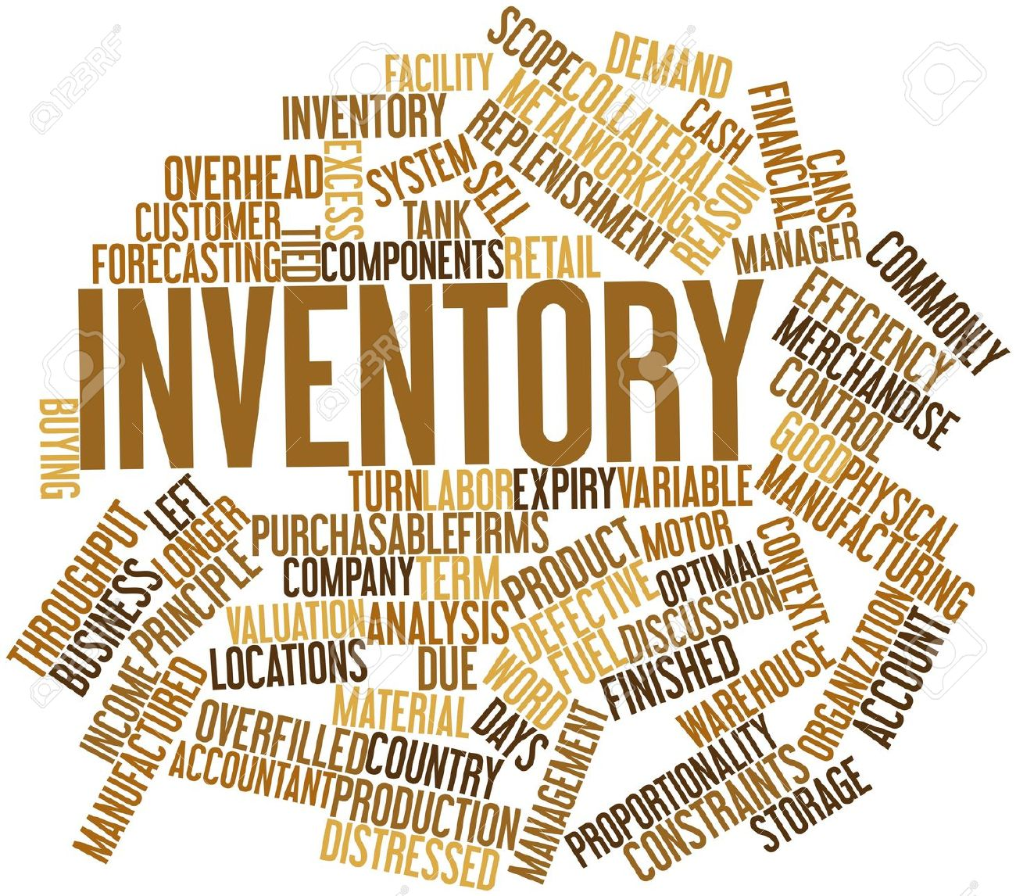

The inventory can also help countries to identify the manufacturers, suppliers and donors of the obsolete pesticides. These organizations are of particular importance as they are often willing to provide resources for subsequent safeguarding and disposal activities. The inventory process can also identify reasons for the accumulation of the obsolete pesticides and can assist in the development of a baseline for the planning of measures to prevent their accumulation in the future. An inventory has, however, a finite validity, and any subsequent clean-up or disposal project should be planned to take place as soon as possible after the collection and interpretation of the inventory data.

A reliable inventory provides a firm basis for:
• prioritizing pesticides sites according to the level of risk that they pose to public health and the environment;
• planning safeguarding activities;
• identifying the manufacturers, suppliers and donors of pesticides who may be willing to provide resources for their disposal and remediation;
• planning campaigns for the private sector to surrender hazardous pesticides stocks;

• planning the subsequent disposal of obsolete stocks;
• planning the remediation of contaminated sites;
• developing a programme to avoid the reoccurrence of obsolete pesticides.

The inventory is therefore an essential first step in the disposal phase of any project and the quality of the data collected at this initial stage will have a significant impact on the implementation of all subsequent phases in the disposal programme.

Some Useful Examples of Inventories:
Qualitative and Quantitative Inventory of Pesticide Application, Transport and Storage;
Identification of the existing positive lists of pesticides and quantities used in each country, the variety of crops cultivated in the region or site of interest, principal pests, requiring treatment with pesticides, methods of application, storage and disposal, plant protection policy, the trend of pesticide application.

Inventories of Pesticide Production, Import, Export, Number of Producers, Formulation of Companies and Suppliers and Main Users;
Lists of producers and produced and formulated pesticides in each country and export of pesticides between those countries. Lists of the imported pesticides. Practice of the pesticide trade and distribution. Packing and labeling. Special training requirements, licensing.
Inventory for identification of the Responsible Authorities for Pesticide Regulation and Laws
Identification of the principle organizations responsible for pesticide regulation and enforcement. Inventory of the role of the local country Ministry of Agriculture, Ministry of Health, Ministry of Environment and Ministry of Internal Affairs in pesticide regulation and laws. Interagencies collaborating activity. The role of non-governmental ecological organizations. Who is authorized to have a right for “veto” in decision-making. Implementation and control.
Inventory on the Economic Parameters Underlying the Usage Patterns of Pesticides
Identification of the potential loss related to plant diseases, pests and weeds. Costs of the pesticides and their application. Cost/benefit analysis. Inventory of the crops cultivated and crop production loss from non-treated crops. Study on the existing experience in the countries.

Classification of the active agents
Classification of pesticide active ingredients in connection to water pollution and ecotoxicity hazard. Data on health hazard, ecotoxicity, solubility, transformation rate, extent of sorption, persistence in the environment, leaching in soil, etc. were summarized using international specialized databanks. Classification of pesticides in several categories based in EU and other classification schemes has to be performed.
Formulation of Common Procedures and Criteria for Admission of Active Agents in the Products for Sale
Common criteria based on ecotoxicity, behavior and persistence in the environment, in order to protect soil and aquatic ecosystems and drinking water. General approaches for common procedures for pesticide registration
Positive List for Active Ingredients
Classification of pesticides in relation with established criteria and risk estimation. Recommended list of pesticides.

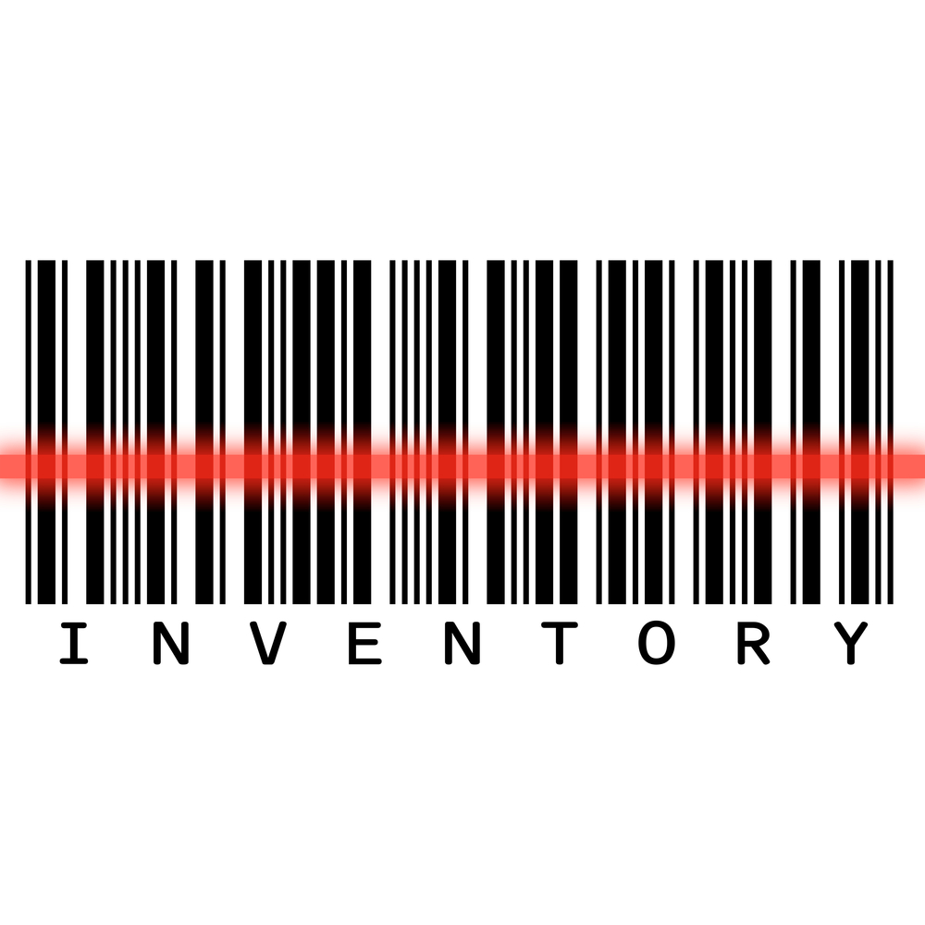

Measures for Reducing the Environmental Impact of Approved Active Substances
Development of model legislation with special requirements for pesticide use in every region of interest. Recommendation of legal policy and management framework, required to improve the environmental situation in concern to pesticide contamination in each particular region. Preparation of a manual with recommended measures to be used by farmers.
Elaboration of a Strategy for Pesticide Use in different environmental polluted media
Existing OECD/EU approaches were used and adapted to the current situation each particular region with respect of elimination of all pesticide active ingredients, which pose a threat to the sustainability of key functions of the agriculture soil and the surface water in the river basin: drinking water, aquatic ecosystems and fisheries.

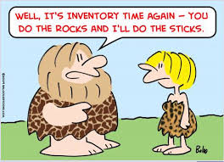

Bibliography

1. Chemicals as Intentional and Accidental Global Environmental Threats, 2006, Lubomir Simeonov and Elisabeta Chirila (eds), NATO Science for Peace and Security, Series C: Environmental Security, Springer Science+Business Media, Dordrecht, ISBN 1-4020-5096-8.
2. Soil Chemical Pollution, Risk Assessment, Remediation and Security, 2008, Lubomir Simeonov and Vardan Sargsyan (eds), NATO Science for Peace and Security, Series C: Environmental Security, Springer Science+Business Media, Dordrecht, ISBN 978-1-4020-8255-9.
3. Exposure and Risk Assessment of Chemical Pollution - Contemporary Methodology, 2009, Lubomir I. Simeonov and Mahmoud A. Hassanien (eds), NATO Science for Peace and Security, Series C: Environmental Security, Springer Science+Business Media, Dordrecht, ISBN 978-90-481-2333-9.
4. Environmental Heavy Metal Pollution and Effects on Child Mental Development, 2011, Lubomir I. Simeonov, Mihail V. Kochubovsky, Biana G. Simeonova (eds), NATO Science for Peace and Security, Series C: Environmental Security, Springer Science+Business Media, Dordrecht, ISBN 978-94-007-0252-3.
5. Environmental Security Assessment and Management of Obsolete Pesticides in Southeast Europe, 2013, L.I.Simeonov, F.Z.Makaev, B.G.Simeonova (eds), NATO Science for Peace and Security, Series C: Environmental Security, Springer Science+Business Media, Dordrecht, ISBN 978-94-007-6460.
6. The Preparation of Inventories of Pesticides and Contaminated Materials, 2010, FAO Pesticide Disposal Series,Volume 1, Planning, 2010 Rome, ISBN 978-95-5-106637-9, http://www.fao.org/docrep/013/i1724e/i1724e.pdf

https://toxoer.com

Project coordinator: Ana I. Morales
Headquarters office in Salamanca.
Dept. Building, Campus Miguel de Unamuno, 37007.
Contact Phone: +34 663 056 665

