Pesticides. Awareness Rising. International Conventions

Lubomir Simeonov, Yordan Simeonov
Space Research and Technology Institute (SRTI)
Bulgarian Academy of Sciences (BAS)
Acad. G. Bonchev Str., Block 1
1113 Sofia, Bulgaria
lubomir.simeonov@gmail.com

Pesticides. Awareness Rising. International Conventions.
Introductory Notes
The ability of early XX-century synthetic chemists to exploit the large availability of industrial chlorine as a cheap source of chemical diversity resulted in the preparation of a wide range of compounds and materials with large utility in most fields of industrial technology. Several classes of highly-chlorinated organic molecules were found to have strong insecticidal activity, since Paul Hermann Muller (re)discovery of dichloro-diphenyl-trichloroethane (DDT) in 1939. The efforts and the intellectual creativity of industrial chemists within two decades since that historical moment resulted in preparation of new, powerful, cheap and relatively safe organochlorine pesticides, which were applied on agricultural fields in millions of tons in the following decades.
Raise of Production and Application of Pesticides in Agriculture and Elsewhere
Crop protection products, also known as pesticides, are chemical or biological substances used to control unwanted pests that can harm our food, health or environment.
Pesticides are one of the vital tools that help farmers grow healthy crops, protecting our food supply against yield losses and damage caused by weeds, diseases and insects.
Without these products, crop yields and quality would fall, many foodstuffs would be in short supply, and food prices would rise.

Spraying of Pesticides by Airplane (photo by Reuters)
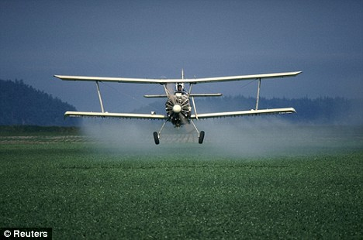

Continued…
For example over 97% of United Kingdom farms use modern pesticides to deal with a range of pest problems. They can be formulated as liquids, granules or powders. Some are used pre-sowing as seed treatments, but most crop protection products are diluted in water and applied to crops using specialized spraying equipment.
Pesticides are also widely used outside agriculture, for example, to improve the quality of gardens, golf courses and sports pitches, and to maintain the safety of our roads and railways.
Advances in product development, formulation and application ensure that modern pesticides are safer, more precisely targeted and more rapidly degraded in the environment than ever before.

A Very Nice and Impressive Photo of the Benefits of Pesticide Application in Agriculture (photo by Colourbox)

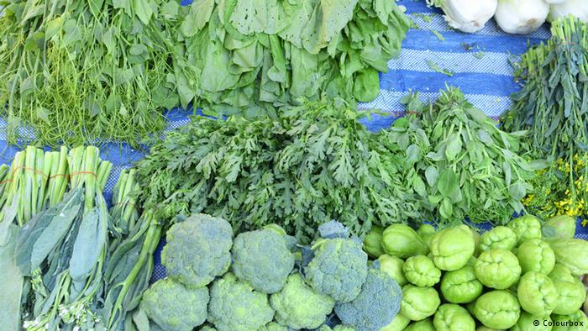

The effect on agricultural landscape as striking since the beginning, both in the beneficial reduction of parasites in cultures and in the improvement in living conditions of the agricultural population, but also, in a soon much less appreciated way, as an immediately apparent decrease of landscape biodiversity.

A prominent Italian poet, writer, and film-maker, Pier Paolo Pasolini, even metaphorized the observation that the flash of summer fireflies had quickly disappeared from summer nights to sorrowfully point of the dangerous side-effect of industrialization on people’s intimate lifestyle. -threatening

Schematic Drawing of the Patterns of Distribution of Pesticides in Environmental Media, Contaminating Air, Soil and Water

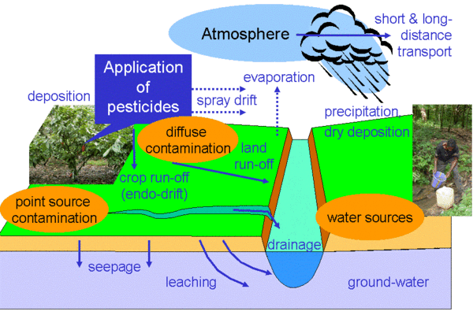

The Controversial Fate of Honey Bees
The world of bees is fascinating and varied. The common honeybee is the most well-known and well-studied species, but there are thousands of wild bee species that enliven our landscapes and help to pollinate crops and wildflowers. The widely reported threats to honeybees, which cause their colonies to collapse, also jeopardize the lives of these lesser-known and under-appreciated bee species. as malaria, both improving the quality of life
Historically one of the first most disturbing signs for the contradictory nature of pesticides, both useful and harmful, was the fate of honeybees. Millions of honeybees lie dead after being sprayed with an insecticide targeting harmful pest insects, mainly mosquitoes.

Pesticides Affect Wildlife & Birds
Historically the second highly disturbing fact about the application of pesticides and their fate in different environmental media was the life of birds, namely the wildlife bird populations. Environmentalists tried to learn the story from another angle, i.e. the way these chemicals could indirectly affect other creatures in the ecosystem. At the lack of appropriate analytical techniques, the conclusions were based more or less on purely logical reflections, as they compared the decline of bird populations and chemical concentrations in surface waters. The evident link was striking. The rightness of the conclusions of the first environmentalists was confirmed by precision analytical evidence several decades later.

A Front Cover of a Recent Issue of The Nature on Honeybees
The Problem with Bees Fate is still under Discussion and far from Solution

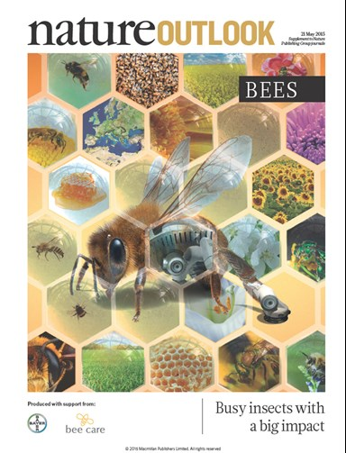

The ways of wildlife and birds poisoning by pesticides are different.
The first way is by ingestion. Birds drink contaminated with pesticides surface water.
Also most of the wildlife birds are dependent on insects for all or part of their diet. The pesticides affect birds by eliminating their food sources. Since these pesticides kill target and non-target species alike, there are fewer flies, grasshoppers, stinkbugs, and caterpillars for the birds to feast on.
The second way is by swallowing directly pesticides, distributed in agricultural fields, by accident or by curiosity. Sometimes it is explained of the numerous causes for population declines in birds, due to changes in the kinds of crops planted in any given year and the amount of fertilizer used to the urbanization of former farmland.

The Fate of Wildlife Birds in the Environment
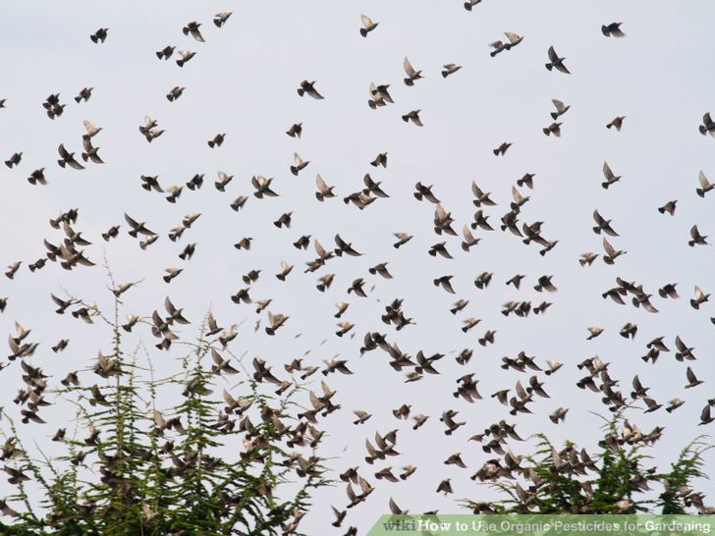

What about human life and heath in the presence of hazardous pesticides?
The opinion of: Dr. Rene’ Dubos “Men are naturally more impressed by diseases which have obvious manifestations, yet some of their worst enemies creep on them unobtrusively.”
Along with the wide use of pesticides in the world, the concerns over their health impacts are rapidly growing. There is a huge body of evidence on the relation between exposure to pesticides and elevated rate of chronic diseases such as different types of: cancers, diabetes, neurodegenerative disorders like Parkinson, Alzheimer, and amyotrophic lateral sclerosis (ALS), birth defects, and reproductive disorders.
Other chronic diseases are respiratory problems, particularly asthma and chronic obstructive pulmonary disease (COPD), cardiovascular disease such as atherosclerosis and coronary artery disease, chronic nephropathies, autoimmune diseases like systemic lupus erythematous and rheumatoid arthritis, chronic fatigue syndrome, and aging.
Nowadays the understanding and knowledge for the toxic effects of pesticides on the human health, environment and biodiversity is on a very high level, because it is backed by the contemporary achievements of analytical chemistry, by thousands of scientific studies and publications, by the strength and efforts of international and national environmental protection agencies, by the legislation power of the organizations which control and check the appearance of new pesticide formulations, etc.
This is the present situation. But what was the situation just several decades ago, when the happiness that the new synthetic chemicals successfully were winning the struggle with harmful pests, both in agriculture and in household, eradicating life-threatening diseases like malaria, and when the production of crops, fruit and vegetables was increased manifold and created hopes and promised to conquer the problem of hunger worldwide…

The Process of Awareness Rising
Fifty years ago, the awareness for the dangerous toxicity of pesticides was a very disputable fact. Nowadays is accepted that it was the activity of the environmentalist Rachel Carson, which gave the initial push of the process of awareness creation. In the late 1950s, Carson turned her attention to conservation, especially environmental problems that she believed were caused by synthetic pesticides. The result was Silent Spring (1962), which brought environmental concerns to the American public. Silent Spring (a spring without singing of the birds) was met with fierce opposition by chemical companies, but it spurred a reversal in national pesticide policy and inspired an environmental movement that led to the creation of the U.S. Environmental Protection Agency (EPA).
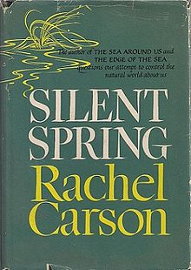

By 1962, since the publication of Rachel Carson’s passionate book “Silent Spring”, an environmental science book, concern for the ecological consequences of uncontrolled application of pesticides and their unstoppable dispersion in the general environment quickly rose, especially when highly populated regions of developed countries started to suffer the effects of widespread contamination as a threat to their own food sources.

The overriding theme of Silent Spring is the powerful—and often negative—effect humans have on the natural world. Carson's main argument is that pesticides have detrimental effects on the environment; she says these are more properly termed "biocides" because their effects are rarely limited to the target pests. DDT (dichloro-diphenyl-trichloroethane) is a prime example, but other synthetic pesticides—many of which are subject to bioaccumulation—are scrutinized. Carson accuses the chemical industry of intentionally spreading disinformation and public officials of accepting industry claims uncritically. Most of the book is devoted to pesticides' effects on natural ecosystems, but four chapters detail cases of human pesticide poisoning, cancer, and other illnesses attributed to pesticides.

Chapters of the Book “Silent Spring” by Rachel Carson

• A Fable for Tomorrow • The Obligation to Endure • Elixirs of Death • Surface Water and Underground Sees • Realms of Soil • Earth’s Green Mantle • Needless Havoc • And No Birds Sing • Rivers of Death • Indiscriminately from the Skies • Beyond the Dreams of Borgias • The Human Price • Through A Narrow Window • One in Every Four • Nature Fights Back • The Rumblings of an Avalanche • The Other Road

A Well-known Photo of Children that Walk towards a DDT Gas Cloud
as
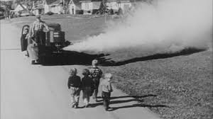

As a consequence of a more than decennial effort, industrialized countries started to limit application of organochlorine pesticides, to ban their production and to enforce limits to their presence as ubiquitous contaminants of water and food. Early concern on the long-term consequences of the large, uncontrolled release of organochlorine pesticides into the environment led to restriction or ban to their use in an increasing number of developed countries, along with the availability of less environmentally persistent insecticides, such as those of the organophosphate and carbamate classes. In particular, ten years after the publication of ‘Silent Spring’, the USA banned DDT.

International Conventions

The Basel Convention
The Basel Convention on the Control of Transboundary Movements of Hazardous Wastes and Their Disposal, is an international treaty that was designed to reduce the movements of hazardous waste between nations, and specifically to prevent transfer of hazardous waste from developed to less developed countries. The Convention is also intended to minimize the amount and toxicity of wastes generated, to ensure their environmentally-sound management as closely as possible to the source of generation, and to assist countries in environmentally sound management of the hazardous and other wastes they generate. The Convention was opened for signature on 22 March 1989, and entered into force on 5 May 1992. As of January 2015, 182 states and the European Union are parties to the Convention.

The Rotterdam Convention
The Rotterdam Convention (formally, the Rotterdam Convention on the Prior Informed Consent Procedure for Certain Hazardous Chemicals and Pesticides in International Trade) is a multilateral treaty to promote shared responsibilities in relation to importation of hazardous chemicals. The Convention promotes open exchange of information and calls on exporters of hazardous chemicals to use proper labeling, include directions on safe handling, and inform purchasers of any known restrictions or bans. Signatory nations can decide whether to allow or ban the importation of chemicals listed in the treaty, and exporting countries are obliged to make sure that producers within their jurisdiction comply. The Rotterdam Convention was signed on 10 September 1998 and was effective from 24 February 2004. As of September 2013, the convention had 154 parties, which includes 153 states and the European Union.

Substances covered under the Rotterdam Convention

2,4,5-T, Alachlor, Aldicarb, Aldrin, Asbestos, Benomyl, Binapacryl, Captafol, Carbofuran, Chlordane, Chlordimeform, Chlorbenzilate, DDT, Dieldrin, Dinitro-ortho-cresol, Dinozeb, 1,2-dibromoethane, Endosulfan, Ethylene dichloride, Ethylene oxide, Fluoroacetamide, Hexachlorocyclohexane, Heptachlor, Hexachlorobenzene, Lindane, Mercury compounds, Methamidophos, Methyl parathion, Monocrotophos, Parathion, Pentachlorophenol, Phosphamidon, Polybrominated biphenyls (PBB), Polychlorinated biphenyls (PCB), Polychlorinated terphenyls (PCT), Tethraethyl lead, Tethamethyl lead, Thiram, Toxaphene, Tributol tin, Tris phosphate. From April/May 2013 were added also: Azynphos-methyl and several industrial chemicals.

The Stockholm Convention

The Stockholm Convention on Persistent Organic Pollutants is an international environmental treaty, signed in 2001 and effective from May 2004, that aims to eliminate or restrict the production and use of Persistent Organic Pollutants (POPs). As of May 2013, there are 179 parties to the Convention, (178 states and the European Union). The Stockholm convention banned or greatly restricted twelve chlorinated organic compounds or classes due to their toxicity and ability to accumulate in the environment and to magnify through the global trophic network. These 12 chemicals have attained the name and have been known since then as “The Dirty Dozen”. Among them are eleven pesticides namely aldrin, chlordane, DDT, dieldrin, endrin, heptachlor, hexachloro-benzene, kepone, lindane, mirex and toxaphene. The Lists of banned chemicals is updated constantly.

Biblioraphy

1. Chemicals as Intentional and Accidental Global Environmental Threats, 2006, Lubomir Simeonov and Elisabeta Chirila (eds), NATO Science for Peace and Security, Series C: Environmental Security, Springer Science+Business Media, Dordrecht, ISBN 1-4020-5096-8.
2. Soil Chemical Pollution, Risk Assessment, Remediation and Security, 2008, Lubomir Simeonov and Vardan Sargsyan (eds), NATO Science for Peace and Security, Series C: Environmental Security, Springer Science+Business Media, Dordrecht, ISBN 978-1-4020-8255-9.
3. Exposure and Risk Assessment of Chemical Pollution - Contemporary Methodology, 2009, Lubomir I. Simeonov and Mahmoud A. Hassanien (eds), NATO Science for Peace and Security, Series C: Environmental Security, Springer Science+Business Media, Dordrecht, ISBN 978-90-481-2333-9.
4. Environmental Heavy Metal Pollution and Effects on Child Mental Development, 2011, Lubomir I. Simeonov, Mihail V. Kochubovsky, Biana G. Simeonova (eds), NATO Science for Peace and Security, Series C: Environmental Security, Springer Science+Business Media, Dordrecht, ISBN 978-94-007-0252-3.
5. Environmental Security Assessment and Management of Obsolete Pesticides in Southeast Europe, 2013, L.I.Simeonov, F.Z.Makaev, B.G.Simeonova (eds), NATO Science for Peace and Security, Series C: Environmental Security, Springer Science+Business Media, Dordrecht, ISBN 978-94-007-6460.gricultural

https://toxoer.com

Project coordinator: Ana I. Morales
Headquarters office in Salamanca.
Dept. Building, Campus Miguel de Unamuno, 37007.
Contact Phone: +34 663 056 665

