Basic Knowledge on Pesticides

Lubomir Simeonov, Yordan Simeonov
Space Research and Technology Institute (SRTI)
Bulgarian Academy of Sciences (BAS)
Acad. G. Bonchev Str., Block 1
1113 Sofia, Bulgaria
lubomir.simeonov@gmail.com

Basic Knowledge on Pesticides

What is a pesticide?
Pesticide is:
- A pesticide is a substance or mixture of substances intended for preventing, destroying, repelling or lessening the damage caused by the pest.
- A pesticide can be an insect, plant pathogen, weed, bacteria, bird, etc. They compete with the humans for food, destroy property an, spread diseases.
- A pesticide can be a chemical, biological, antimicrobial, disinfectant agent, etc.
- Many chemical pesticides are poisonous to human and animals.

Agricultural Pharmacy Shop
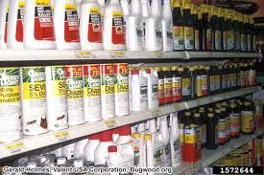

Classification of pesticides on the type of target organisms to destroy:
1. Herbicides are the chemicals used to kill weeds (i.e., unwanted plants), e.g. Borax, Nitrofen;
2. Insecticides - These are used to kill insects, e.g. DDT, BHC;
3. Rodenticides - These are used to kill rodents, e.g. Warfarin, Zinc phosphide;
4. Nematicides - These are used to kill plant-parasitic nematodes, e.g. DBCP, Phorate;
5. Molluscicides - These are used to kill molluscs, e.g Sodium pentachloridephenate;
6. Fungicides - These are used to kill fungus, e.g. Bordeaux mixture;
7. Algaecides - These are used to kill algae, e.g. Copper sulphate, Endothal;
8. Bactericide - These are used to kill bacteria, e.g. Dichlorophen, Oxolinic acid;
9. Piscicides - These are used to kill fishes, e.g. Trifloromethynitrophenol(TFM).

Crop Duster Spraying Pesticides

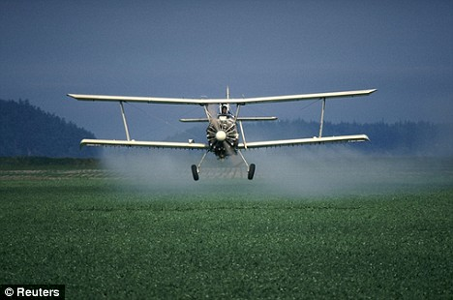

Chemical or synthetic pesticides on the type of chemical compound used:
- Organochlorine - These are non-biodegradable and persist in soil for long time, e.g. DDT, BHC, Endosulfan, Aldrin, etc.
- Organophosphorous - These are esters of alcohols with phosphoric acid or with some other acids. These are very toxic acetyl-cholinesterase inhibitors as a result of which the breakdown of acetyl choline stops. The accumulation of acetyl choline resulting in convulsion paralysis and death, e.g. Malathion.
- Carbamates - They are derived from carbamic acid. Mode of action of carbamates is almost similar to organo- phosphates, e.g. Carbaryl, Dimetilan.
- Synthetic Pyrethroids -These are esters of specific acids: chrysanthemic acid and alcohols as pyrethrolone, cinerolone, jasmolone. They possess excellent insecticidal activity and low mammalian toxicity.
- Organotine compounds – Mostly three substituted organotin compounds are used as pesticides Trialkyl, Tin compounds, Triphenyl- and Tricyclohexyltin compounds. There are recorded cases of affect to on human beings marine organisms. There is no data on long-term effects and existing data on human toxicity and clinical effects are scarce.
- Organomercurial compounds – They are the oldest group of fungicides used for seed dressing. The most used compounds from this group are Methyl, Ethyl, Methoxyethyl, Phenyl Mercury. Organomercurial fungicides possess very high acute and chronic toxicity. The mercury in these compounds accumulates in the tissue of mammals and can go through the trophic chain into humans.
- Dithiocarbamate compounds - They have found a large application as fungicides. They have a low persistence in the environment, low toxicity, and no cumulative effects. However, some of their metabolites can create problems in the environment, like Ethylenethiourea, which has high persistence and is potentially carcinogenic. Toxicity of Dithiocarbamates depend on the chemical structure of their compounds.

Other groups of pesticides, with limited application are the Benzimidazole, Chlorphenoxy and Dipyridiliums compounds.e esters of specific acids: chrysanthemic aciivity and low mammalian toxicity.
Working of Pesticides
Pesticides work in the following ways:
- By blocking the cellular processes of the target organisms in a purely mechanical way, e.g. Spray oils, petroleum oils;
- By destroying or altering the pest’s metabolism, e.g. Rotenone and Cyanide which disrupt respiratory function in pests;
- By disrupting enzyme processes or denature proteins e.g. Inorganic Copper compounds;
- By simulating or interfering with hormones e.g., Phenoxy herbicides;
- By disrupting photosynthesis and preventing the weed plant from producing or storing energy e.g., Triazine.
Pesticides Destroy Pests

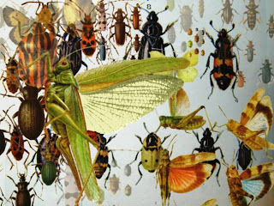

Benefits of Pesticides:
• They are used in public health programs to control vector-born diseases.
• They are used to protect the stored food grains.
• They protect the standing crop in the field. They do not increase the crop yield like fertilizer but by protecting the crop from pests.
• They can be used to control household pests.

Beautiful Photo of Fruits and Vegetables, Maybe Due to Pesticides Application?

Hazards of pesticides:
1. The pesticide industries cause pollution of soil, water and air. The pesticidal residue washed along with rain water, is added to the nearby water resources making it unfit for drinking.
2. They enter the food chain and cause the problems of bioaccumulation or biomagnification.
3. They are not target specific hence they also kills non-pest insects. They adversely affect the mechanism of entomophily.
4. Continuous and indiscriminate use of pesticides may develop resistance in insect pest like the so called superpest and superbugs.

A Schematic Drawing of the Pesticide Cycle in the Environment

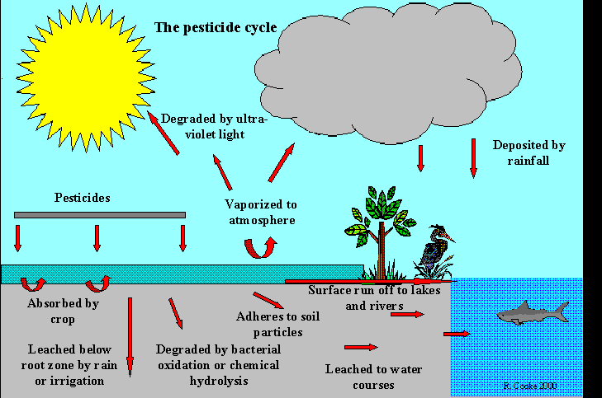

Hazards of Pesticides, continued:
5. They are non-biodegradable and affect the balance of ecosystem.
6. They are highly toxic in nature and if not handled carefully, they can cause serious health problems like cancer, deformities and disease.
7. Accidents in pesticides manufacturing units cause great loss of human life e.g. Bolsover (England, 1968), Seveso(Italy,1976), Bhopal Gas Tragedy (India,1984).

Pesticides Affect Human Health

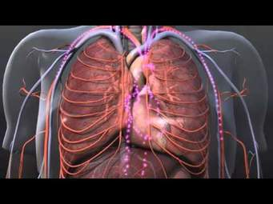

The Bhopal Gas Tragedy:
- The worst industrial disaster in the history of the world is related to pesticide production. This Occurred at Union Carbide Factory in Bhopal, India on Dec. 3, 1984.
- In this incident, Methyl Isocyanide (MIC) – an ingredient in the production of the insecticide Carbaryl, escaped into the atmosphere killing more than 3,000 people within a few hours, another 8000 died within 3 days and another 8000 died from related with the gas poisoning other diseases.
- The insecticide, Carbaryl, itself is a highly toxic chemical and carcinogen (cancer causing agent) to humans.
- The tragedy occurred due to lack of adequate safeguards in the storing of the chemical and lack of adequate warning to the public. Pesticides such as Lindane and Sevin are still being stored in unsafe manner in the now abandoned factory.

Mass Demonstrations Against Union Carbide and Dow Chemicals
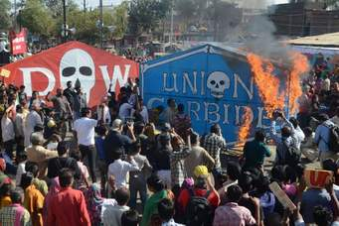

Safe alternative to pesticides
• Integrated Pest Management (IPM) is an effective and environmentally sensitive approach to pest management that relies on a combination of common-sense practices.
• IPM programs use current, comprehensive information on the life cycles of pests and their interaction with the environment.
• These include use of pest resistant or tolerant, predators, and pathogens, use of parasites, summer ploughing, late planting, quarantine measures etc.
Biological control methods:
• It include the use of living beneficial organisms, called natural enemies to control pests.
• Biological control is an important part of any Integrated Pest Management program. All insect and mites have some natural enemies.
• Managing these enemies can effectively control many pest. There are three components of the biological control - Importation, Conservation, Augmentation.
Bio-Pesticides:
• These are most effective, important and commercially viable because these are inexpensive, cause no pollution and pose no threat to human health.
• It include naturally available agents in nature e.g. Viruses - Nuclear polyhedrosis virus; Bacteria -Bacillus thuringiensis; Fungi -Metarhizium, Beauveria
• It also includes the use of natural extracts obtained from plants and microbes e.g. Azadiractin from neem, Nicotine from tobacco and others.

Bibliography
- Chemicals as Intentional and Accidental Global Environmental Threats, 2006, Lubomir Simeonov and Elisabeta Chirila (eds), NATO Science for Peace and Security, Series C: Environmental Security, Springer Science+Business Media, Dordrecht, ISBN 1-4020-5096-8.
- Soil Chemical Pollution, Risk Assessment, Remediation and Security, 2008, Lubomir Simeonov and Vardan Sargsyan (eds), NATO Science for Peace and Security, Series C: Environmental Security, Springer Science+Business Media, Dordrecht, ISBN 978-1-4020-8255-9.
- Exposure and Risk Assessment of Chemical Pollution - Contemporary Methodology, 2009, Lubomir I. Simeonov and Mahmoud A. Hassanien (eds), NATO Science for Peace and Security, Series C: Environmental Security, Springer Science+Business Media, Dordrecht, ISBN 978-90-481-2333-9.
- Environmental Heavy Metal Pollution and Effects on Child Mental Development, 2011, Lubomir I. Simeonov, Mihail V. Kochubovsky, Biana G. Simeonova (eds), NATO Science for Peace and Security, Series C: Environmental Security, Springer Science+Business Media, Dordrecht, ISBN 978-94-007-0252-3.
- Environmental Security Assessment and Management of Obsolete Pesticides in Southeast Europe, 2013, L.I.Simeonov, F.Z.Makaev, B.G.Simeonova (eds), NATO Science for Peace and Security, Series C: Environmental Security, Springer Science+Business Media, Dordrecht, ISBN 978-94-007-6460.

https://toxoer.com

Project coordinator: Ana I. Morales
Headquarters office in Salamanca.
Dept. Building, Campus Miguel de Unamuno, 37007.
Contact Phone: +34 663 056 665

